LOGICAL REASONING: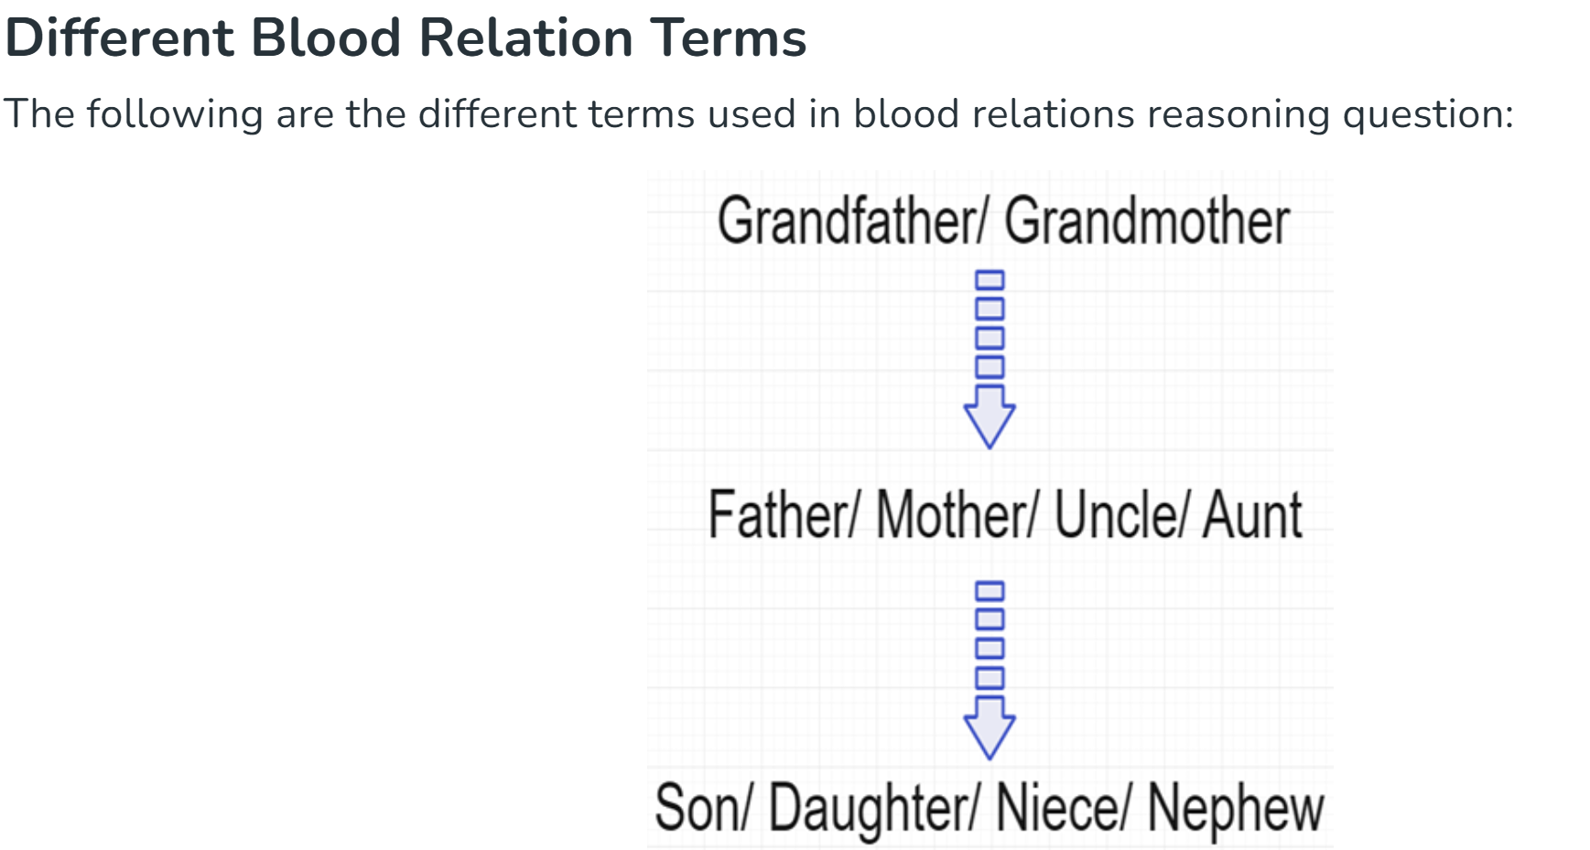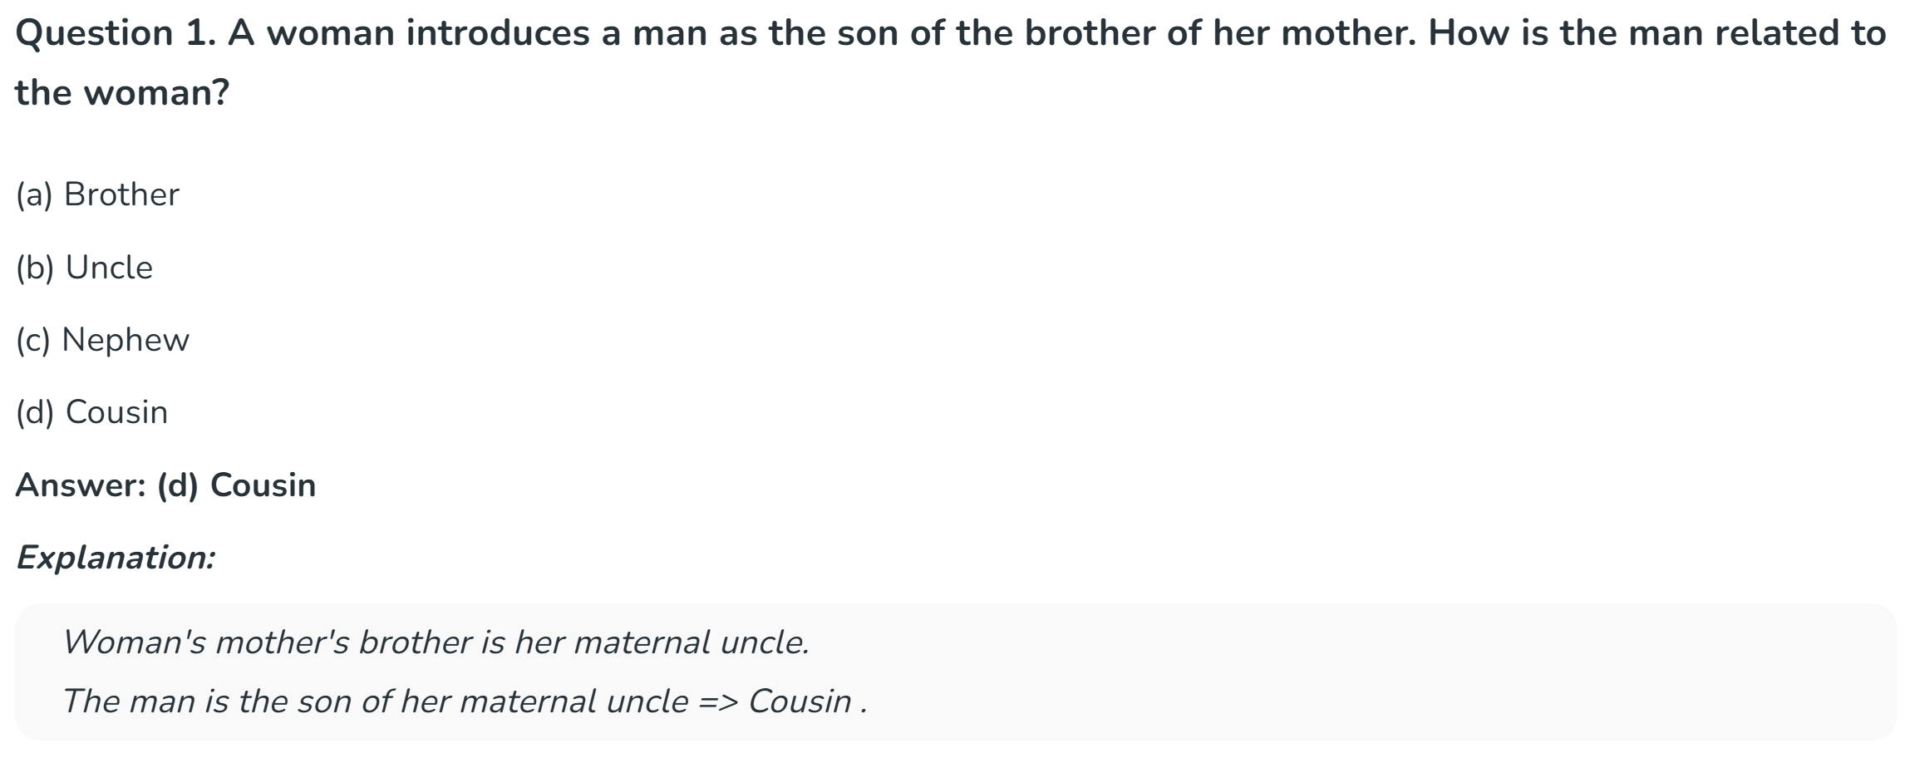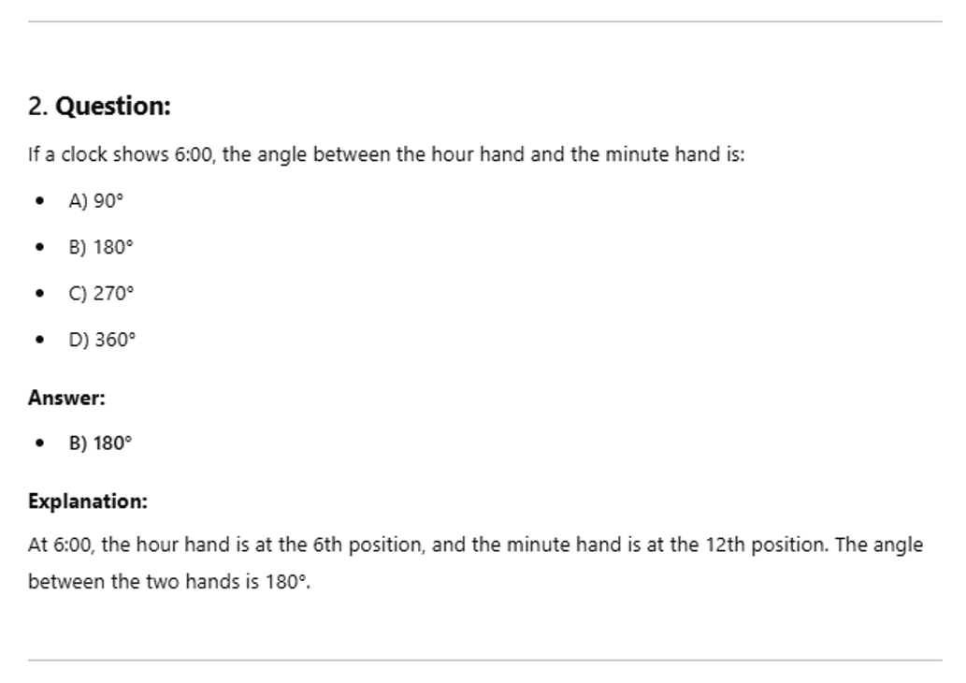
3. A cube is painted green on all faces. It is cut into 64 smaller cubes of equal size. How many cubes have no face painted?
- 8
- 16
- 12
- 10
4x4x4
1 cube – painted – external
Cutting into 64 parts – 4x4x4 – unpainted ..?
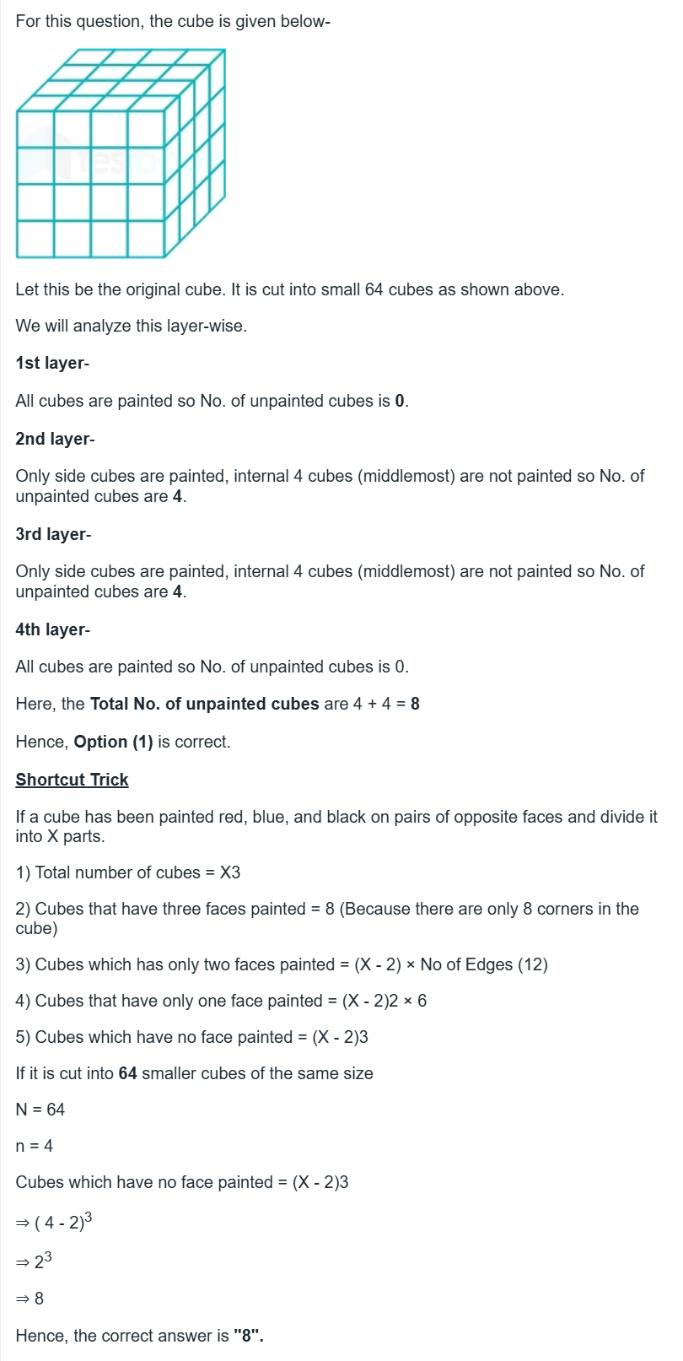

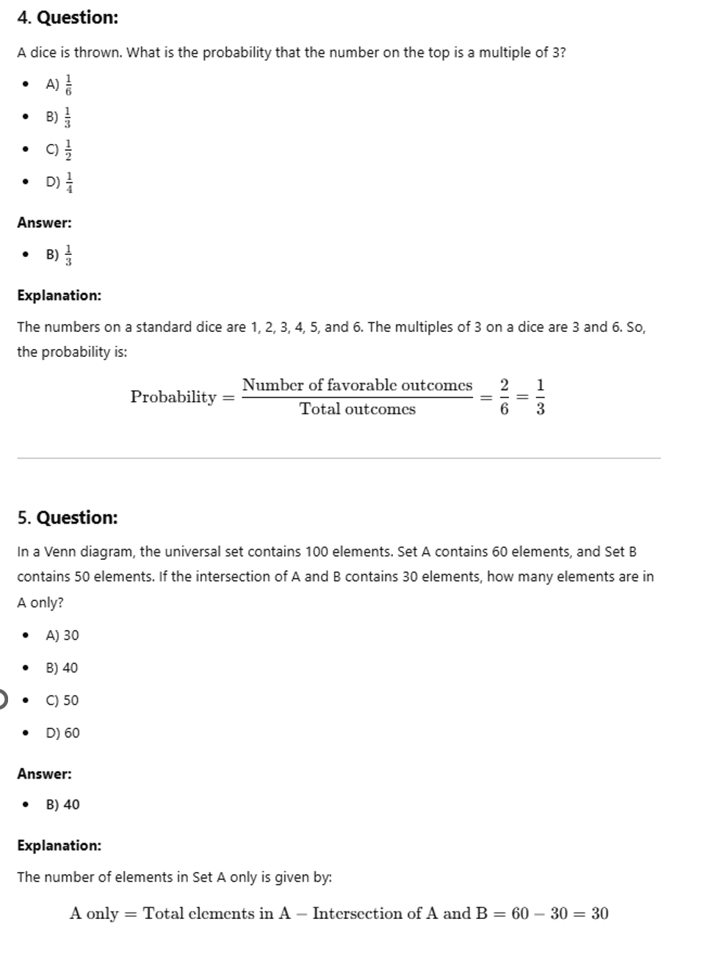

60 30 50
6. If A is the brother of B, C is the sister of B, and B is the father of D, how is D related to A?
(a) Nephew/Niece
(b) Niece
(c) Nephew
(d) Cousin
Answer: (a) Nephew/Niece
Explanation:
A is the brother of B => A and B are siblings.
C is the sister of B => A,B,C are siblings.
B is the father of D => D is nephew / niece for both A and B

7. If today is wednesday what day of the week will be 100 days from today
- Friday
- Tuesday
- Wednesday
- Thursday
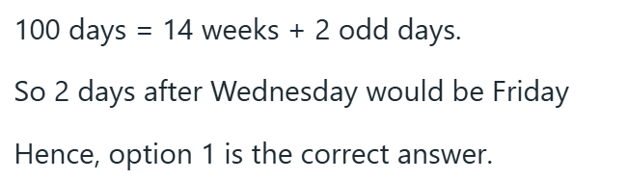

Types of Seating Arrangement Questions
The questions on Seating arrangement are the most common types of questions asked in reasoning in all entrance exams. There are different types of problems with the concept of seating arrangement as follows.
- Linear Arrangement
- Square/Rectangular Arrangement
- Circular Arrangement
- Triangular arrangement
- Hexagonal arrangement
- Pentagon arrangement.
- Combination of the above.

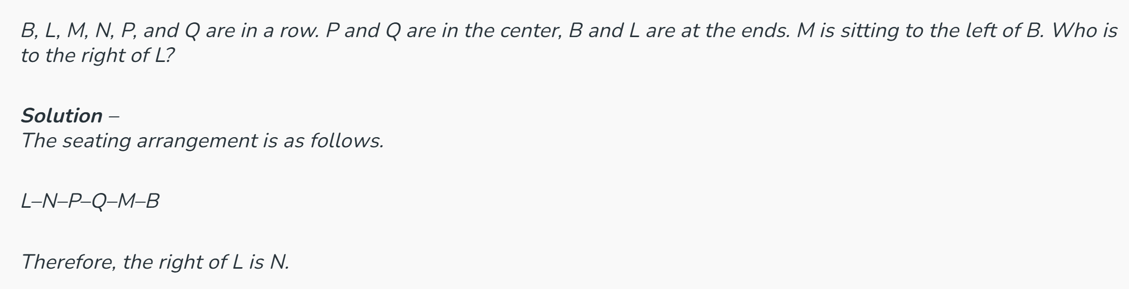

L_ N_ P_ Q_M _ B_

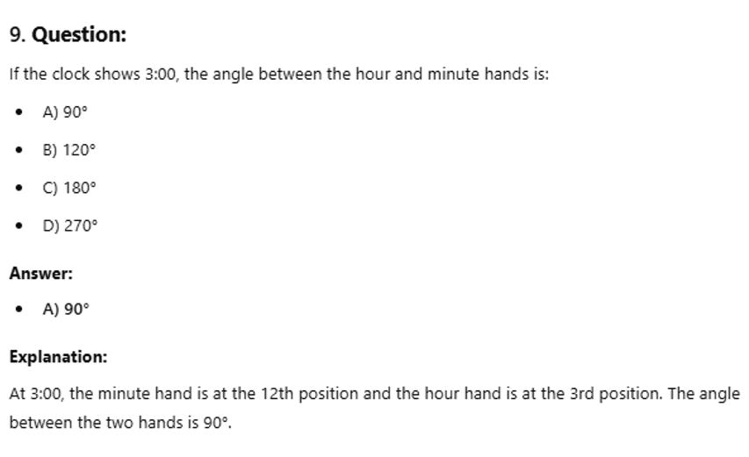

10. If A is the sister of B, B is the daughter of C, and C is the wife of D, how is D related to A?
(a) Father
(b) Uncle
(c) Grand Father
(d) Cousin
Answer: (a) Father
Explanation:
A is the sister of B => A and B are siblings.
B is the daughter of C => C is the mother of A and B .
C is the wife of D => D is husband to C => D is A's and B's Father.
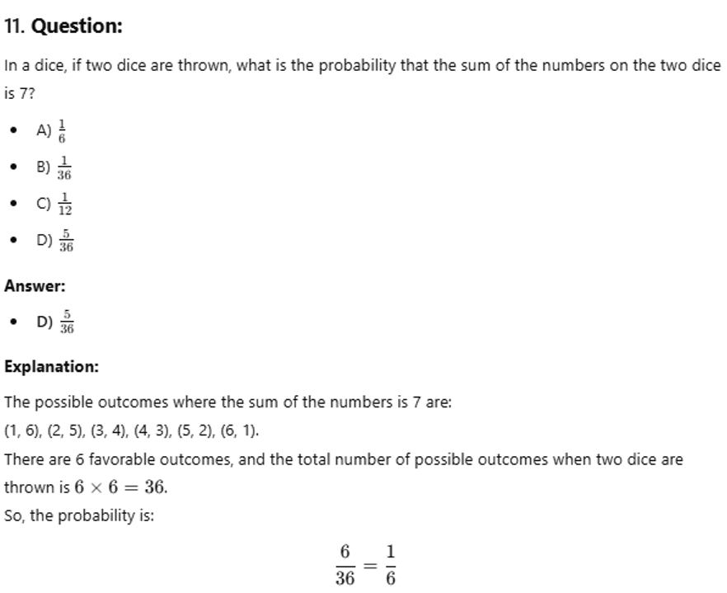

12. If A is the husband of B, B is the mother of C, and C is the wife of D, how is A related to D?
A – b
C - d
(a) Father-in-law
(b) Grandfather
(c) Nephew
(d) Cousin
Answer: (a) Father-in-law
Explanation:
A is husband of B.
B is mother of C => A is father of C.
C is wife of D => D is son-in-law of A / A is father-in-law of D.
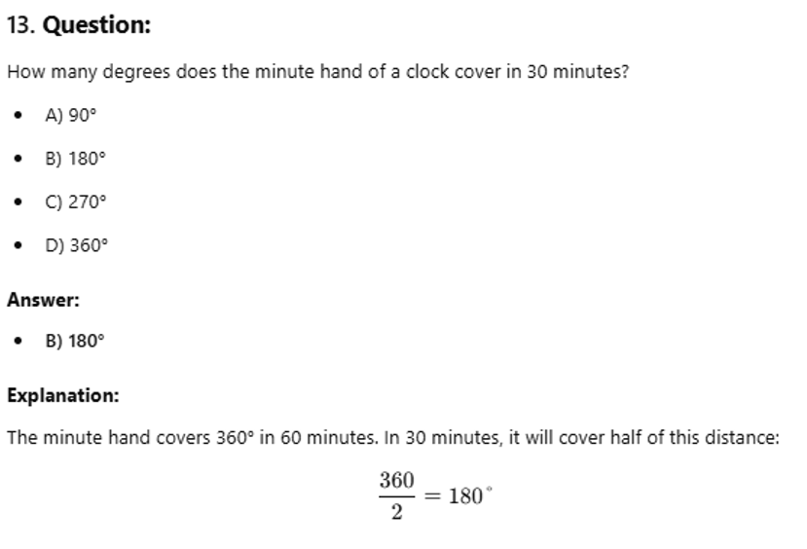

14. If A is the sister of B, B is the daughter of C, C is the wife of D, and D is the brother of E, how is E related to A?
(a) Uncle
(b) Grandfather
(c) Nephew
(d) Cousin
Answer: (a) Uncle
Explanation:
A is sister of B => A and B are siblings.
B is the daughter of C => C is a Parent(Mother/Father) of A and B.
C is the wife of D => C is the mother and D is the father of A and B.
D is the brother of E => E is Paternal Uncle/Aunt for A and B.

15.CUBES:
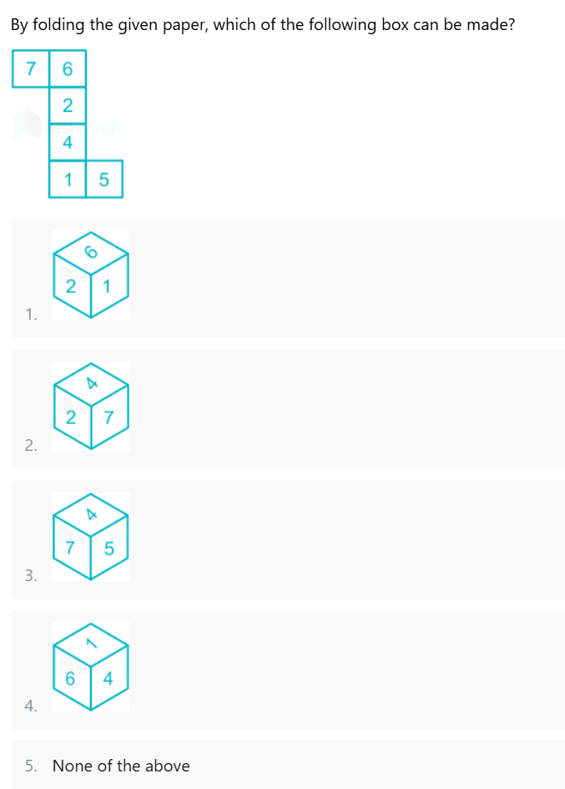
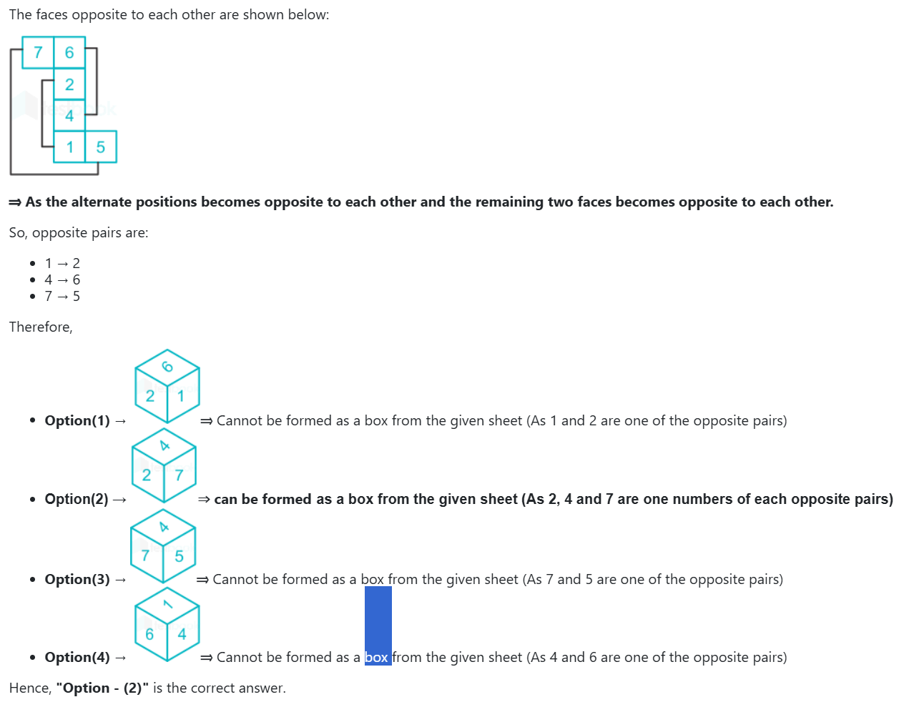

1,1 1,3 1,5
2,2 2,4 2,6
3,1 3,3 3,5
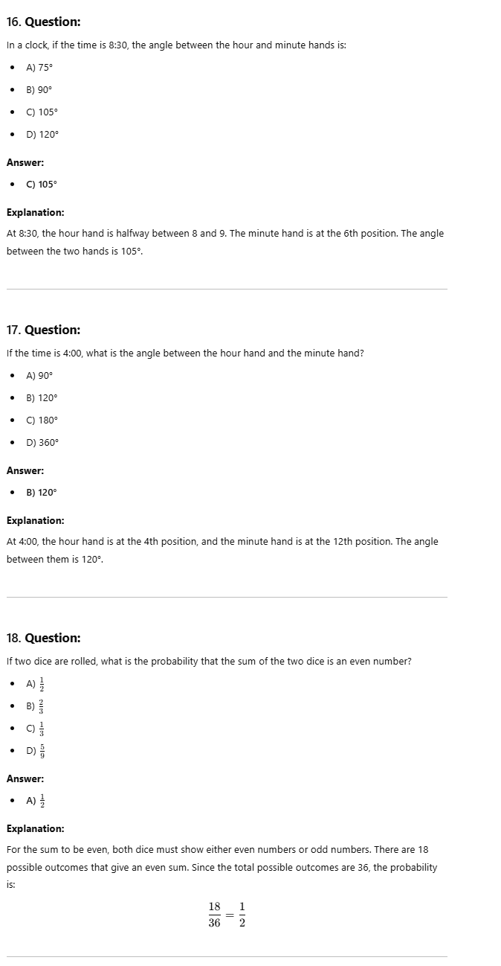
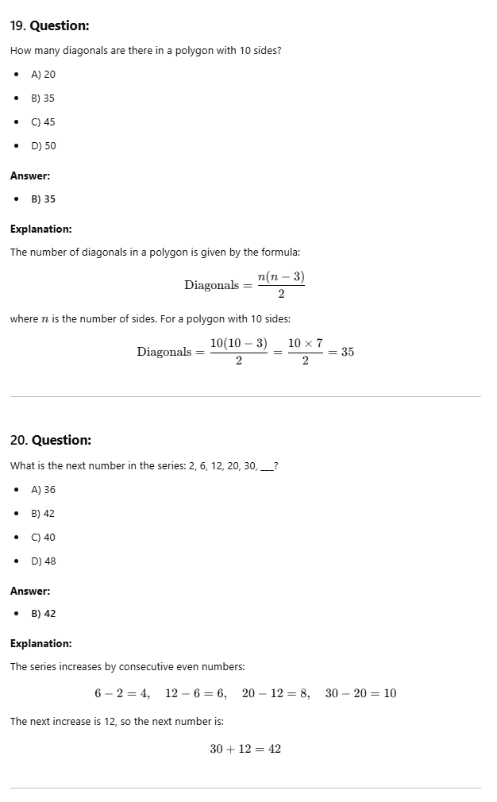
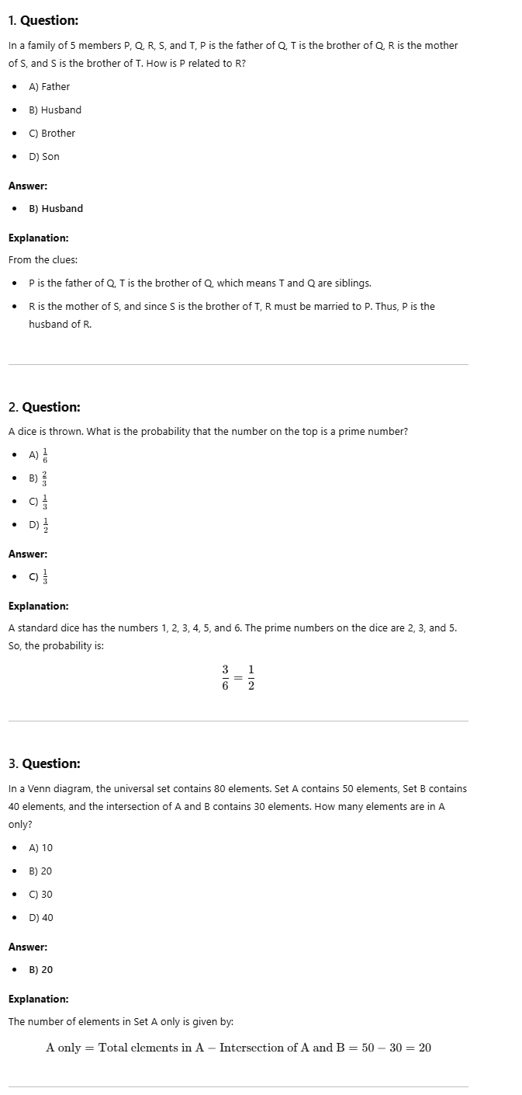
4. If Today Is Wednesday, what will be the day after 50 days
If today is wednesday,what day of the will it be 50 days from today ?
A week has 7 days " Sunday, Monday, Tuesday, Wednesday, Thursday, Friday, Saturday ".
50 / 7 = 7 ( Remainder = 1)
So you can say that after multiples of 7 days, the day will repeat itself as wednesday.
Hence after 49 days Wednesday will occur again.
So we calculate after the remainder (1) , the answer is Thursday.
5.
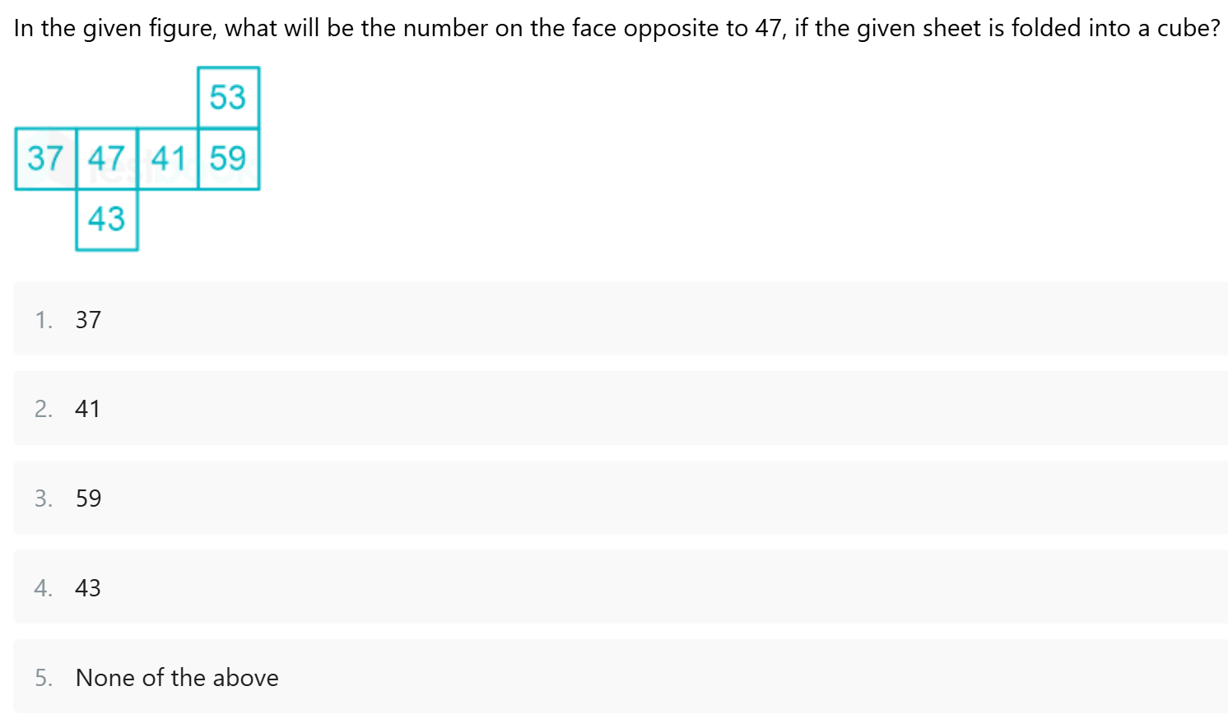
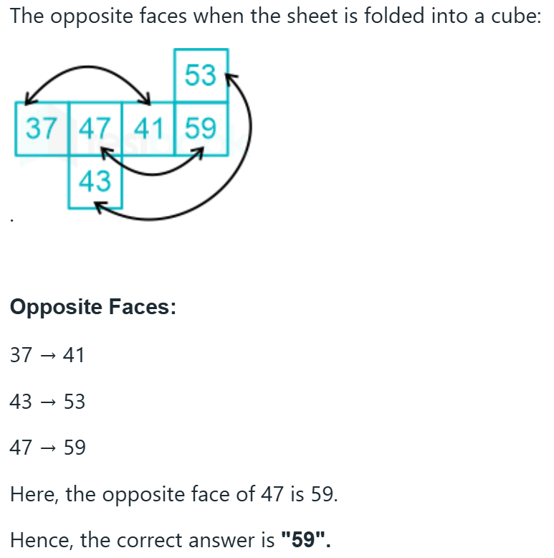

6. If A is the brother of B, B is the son of C, C is the daughter of D, and D is the wife of E, how is E related to B?
D - e
c
A - b
(a) Uncle
(b) Grandfather
(c) Mother
(d) Grandmother
Answer: (b) Grandfather

Explanation:
A is brother of B => A and B are siblings.
B is the son of C => C is a Parent of A and B.
C is the daughter of D => C is mother of A and B => D is Maternal Grandparent for A and B.
D is the wife of E => D is the Maternal Grandmother and E is the Maternal Grandfather for A and B.
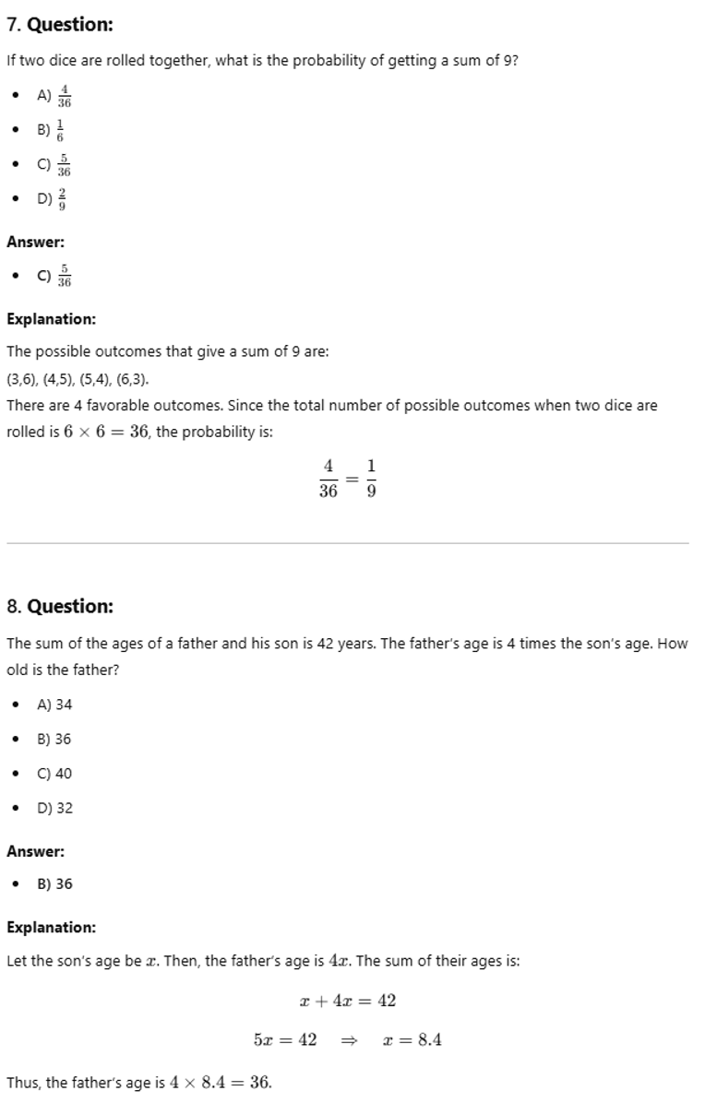
9. What is the angle between the hour hand and the minute hand on a clock if the time is 3:15? 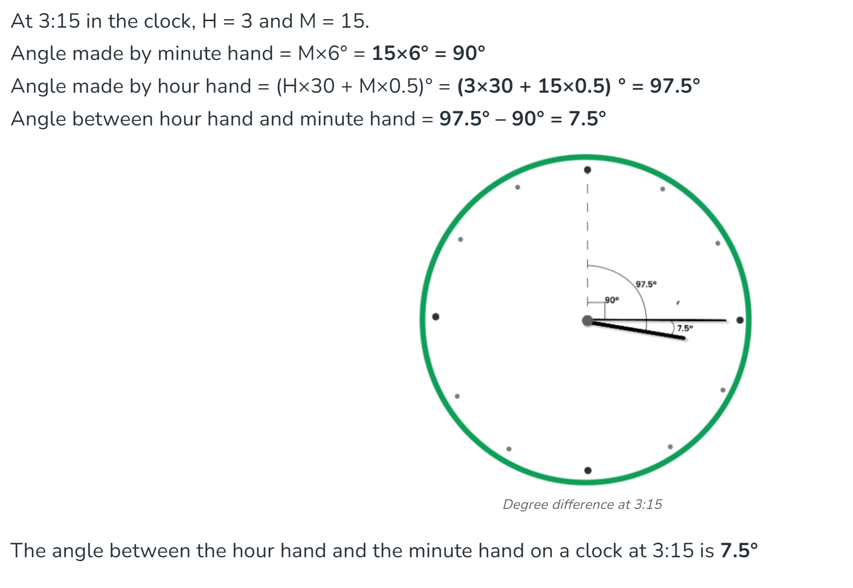
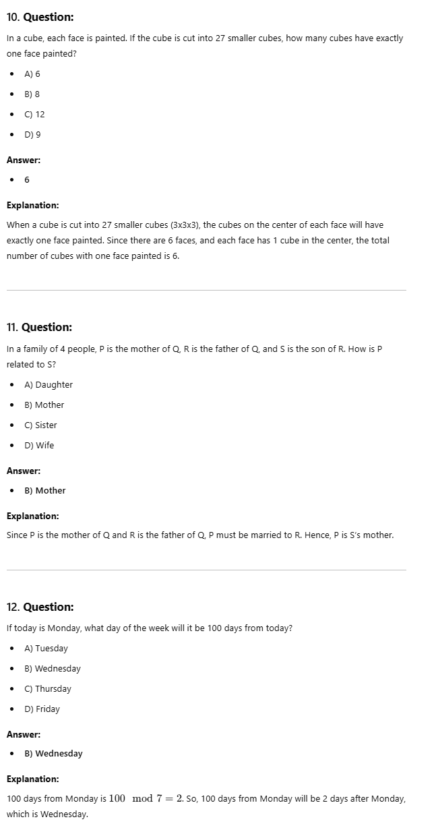
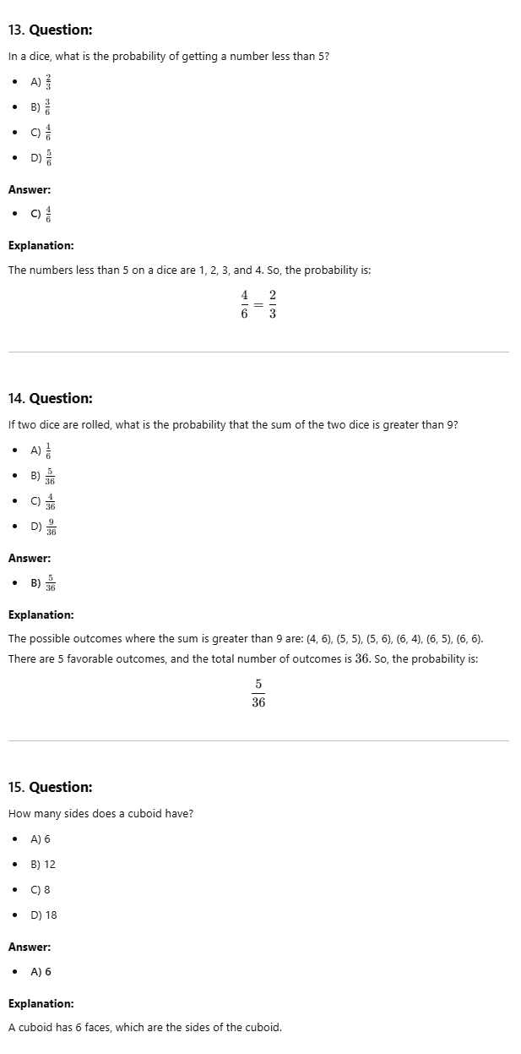
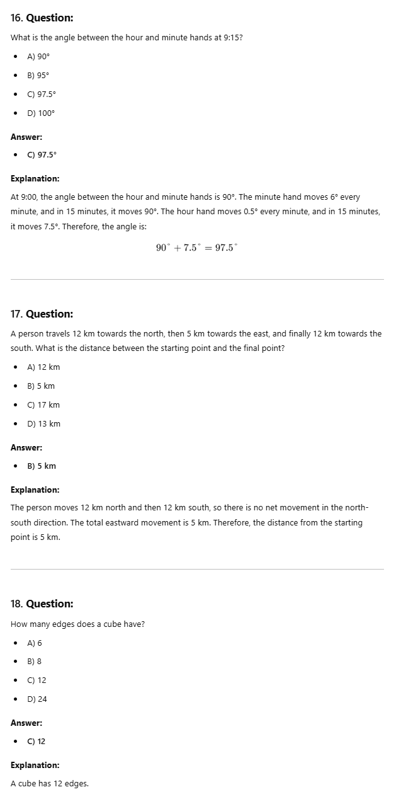
12

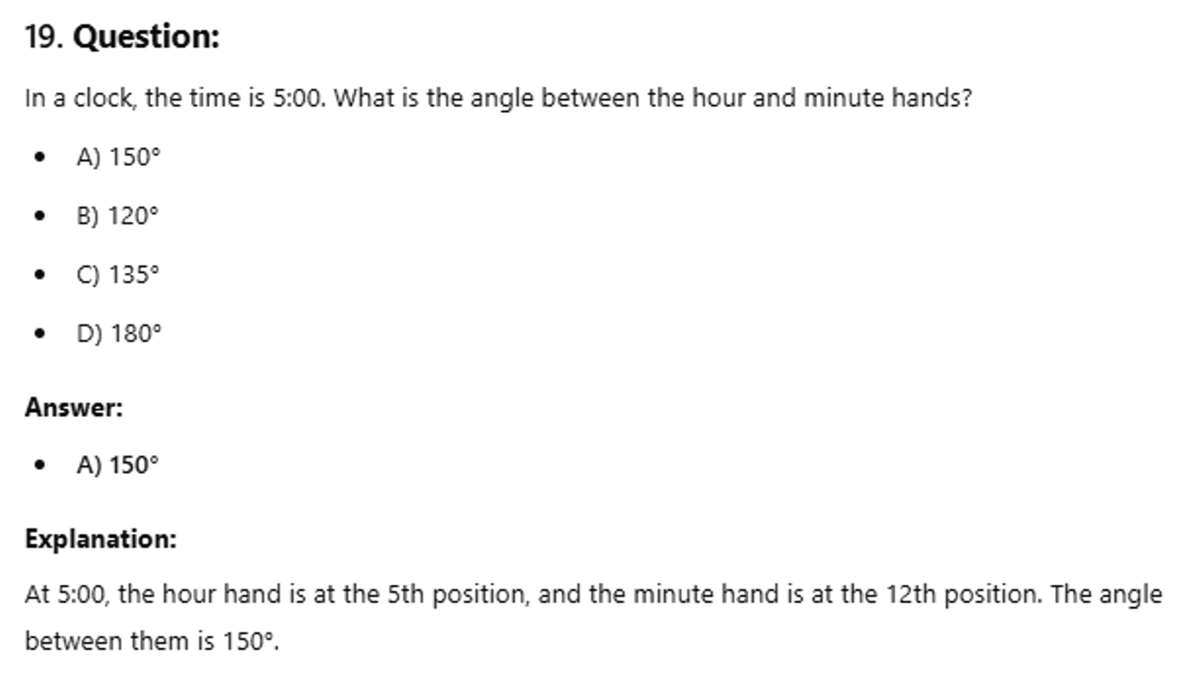
20.
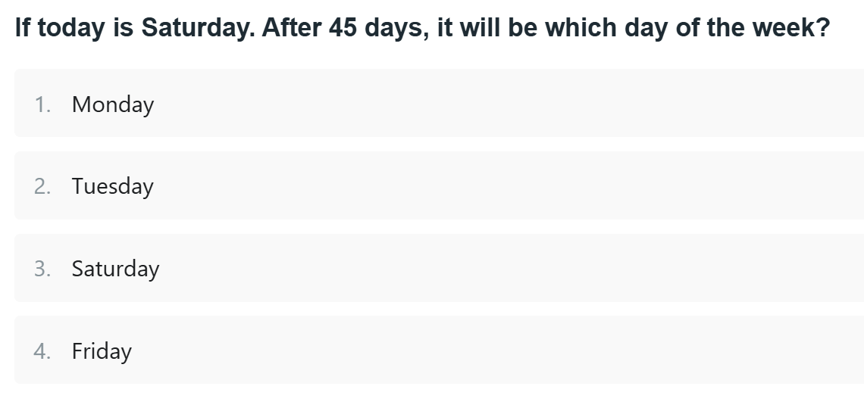
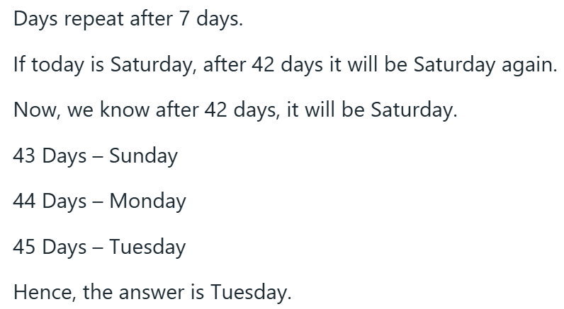

ANALOGIES:
1. Book is to Reading as Fork is to:
A) Drawing
B) Writing
C) Stirring
D) Eating
Solution: A book is used for reading, just as a fork is used for eating.
Answer: D) Eating

2. Finger is to Hand as Toe is to:
A) Knee
B) Foot
C) Leg
D) Arm
Solution: A finger is a part of the hand, just as a toe is a part of the foot.
Answer: B) Foot

3. Cat is to Kitten as Dog is to:
A) Puppy
B) Calf
C) Cub
D) Lamb
Solution: A kitten is a young cat, just as a puppy is a young dog.
Answer: A) Puppy

4. Sun is to Day as Moon is to:
A) Night
B) Light
C) Sky
D) Cloud
Solution: The sun is primarily associated with the day, just as the moon is primarily associated with the night.
Answer: A) Night

5. King is to Queen as Prince is to:
A) Princess
B) Duke
C) Lord
D) Knight
Solution: A king is married to a queen, just as a prince is married to a princess.
Answer: A) Princess
LETTER SERIES:
Sure! Below are 20 multiple-choice questions (MCQs) based on Letter and Symbol Series, along with clear solutions and explanations. These types of questions test your ability to recognize patterns in sequences of letters, numbers, and symbols.

1. SCD, TEF, UGH, ____, WKL
A) CMN
B) UJI
C) VIJ
D) IJT
Solution: Look at the pattern for each position:
- First letters: S → T → U → V → W (Increasing by 1 in the alphabet)
- Second letters: C → E → G → I → K (Increasing by 2 in the alphabet)
- Third letters: D → F → H → J → L (Increasing by 2 in the alphabet)
So, the missing term is VIJ.
Answer: C) VIJ
2. A1B, B2C, C3D, D4E, ____
A) E5F
B) E4F
C) E5G
D) F6G
Solution:
- The first letters are: A → B → C → D → E (increasing by 1).
- The numbers are: 1 → 2 → 3 → 4 → 5 (increasing by 1).
- The last letters are: B → C → D → E → F (increasing by 1).
Thus, the next term is E5F.
Answer: A) E5F

3. A1B, B2C, C3D, ____, E5F
A) D4E
B) D4F
C) D3E
D) D5E
Solution:
- The first letters increase alphabetically: A → B → C → D → E.
- The numbers increase by 1: 1 → 2 → 3 → 4 → 5.
- The last letters also increase alphabetically: B → C → D → E → F.
Thus, the missing term is D4E.
Answer: A) D4E

4. A1B, C3D, E5F, G7H, ____
A) I9J
B) I8J
C) I7J
D) H9I
Solution:
- The first letters are: A → C → E → G → I (increasing by 2).
- The numbers are: 1 → 3 → 5 → 7 → 9 (increasing by 2).
- The last letters are: B → D → F → H → J (increasing by 2).
Thus, the next term is I9J.
Answer: A) I9J
5. XYZ, YZA, ZAB, ABC, ____
A) BCD
B) ABC
C) CDE
D) CDB
Solution:
- The first letters are: X → Y → Z → A → B (increasing by 1 in the alphabet, looping back after Z).
- The second letters are: Y → Z → A → B → C (increasing by 1 in the alphabet).
- The third letters are: Z → A → B → C → D (increasing by 1 in the alphabet).
Thus, the next term is BCD.
Answer: A) BCD
LOGICAL PROBLEMS:
1.
All Lamels are Signots with buttons.
No yellow Signots have buttons.
No Lamels are yellow.
If the first two statements are true, the third statement is
true
false
uncertain
Answer: Option
Explanation:
We know that there are Signots with buttons, or Lamels, and that there are yellow Signots, which have no buttons. Therefore, Lamels do not have buttons and cannot be yellow.

2.
drugstore- market- hotel
The hotel is two blocks east of the drugstore.
The market is one block west of the hotel.
The drugstore is west of the market.
If the first two statements are true, the third statement is
true
false
uncertain

3.
A toothpick is useful.
Useful things are valuable.
A toothpick is valuable.
If the first two statements are true, the third statement is
true
false
uncertain
Answer: Option
Explanation:
To the extent that a toothpick is useful, it has value.
4.
Fact 1: | All chickens are birds.
Fact 2: | Some chickens are hens.
Fact 3: | Female birds lay eggs.
If the first three statements are facts, which of the following statements must also be a fact?
I: | All birds lay eggs.
II: | Some Hens are birds.
III: | Some chickens are not hens.
I only
II only
II and III only
None of the statements is a known fact.
Answer: Option
Explanation:
The first statement cannot be true because only female birds lay eggs. Statement II is true because some hens are chickens and all chickens are birds. Statement III is also true because if only some chickens are hens, then some must not be hens.
5.
Fact 1: | All hats have brims.
Fact 2: | There are black hats and blue hats.
Fact 3: | Baseball caps are hats.
If the first three statements are facts, which of the following statements must also be a fact?
I: | All caps have brims.
II: | Some baseball caps are blue.
III: | Baseball caps have no brims.
I only
II only
II and III only
None of the statements is a known fact.
Answer: Option
Explanation:
All baseball caps have brims, since baseball caps are hats (Fact 3) and all hats have brims (Fact 1). This rules out statement III, but it doesn't follow that all caps, a category that may include caps that are not baseball caps, have brims (statement I). Statement II cannot be confirmed, either, since it is possible, given the information, that all baseball caps are black.

6. Find out the alternative figure which contains figure (X) as its part.
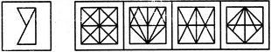
(X) (1) (2) (3) (4)
Answer: Option
Explanation:
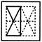

7. Find the number of triangles in the given figure.
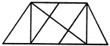
8
10
12
14
Answer: Option
Explanation:
The figure may be labelled as shown.
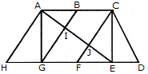
The simplest triangles are AHG, AIG, AIB, JFE, CJE and CED i.e. 6 in number.
The triangles composed of two components each are ABG, CFE, ACJ and EGI i.e. 4 in number.
The triangles composed of three components each are ACE, AGE and CFD i.e. 3 in number.
There is only one triangle i.e. AHE composed of four components.
Therefore, There are 6 + 4 + 3 + 1 = 14 triangles in the given figure.
8.Choose the correct water image of the given figure (X) from amongst the four alternatives.
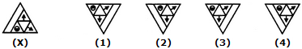
1
2
3
4
Answer: Option 2
9. Select a suitable figure from the four alternatives that would complete the figure matrix.
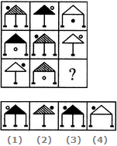
1
2
3
4
Answer: Option 3
10. Which word does NOT belong with the others?
A) Circle
B) Square
C) Rectangle
D) Triangle
Solution: Circle is a shape with no straight edges, while square, rectangle, and triangle all have straight edges.
Answer: A) Circle
11. Which word does NOT belong with the others?
A) Gold
B) Silver
C) Platinum
D) Diamond
Solution: Gold, silver, and platinum are metals, while diamond is a gemstone.
Answer: D) Diamond
12. Which word does NOT belong with the others?
A) Spoon
B) Knife
C) Fork
D) Plate
Solution: Spoon, knife, and fork are utensils used for eating, while plate is a dish used to hold food.
Answer: D) Plate
8. Identify the essential part of the sentence:
"If you wake up early, you will catch the first bus." A) Wake up early
B) You will catch
C) First bus
D) Wake up
Solution:
The core idea is that "you will catch the first bus" if you wake up early. The essential part is about "you will catch the first bus."
Answer: B) You will catch

9. In the sentence, identify the essential part:
"She went to the library to study for the exam." A) She went
B) To the library
C) To study
D) For the exam
Solution:
The essential part is "She went" because it describes the action of the subject.
Answer: A) She went
12. What is the next number in the series:
2, 5, 10, 17, ? A) 24
B) 26
C) 27
D) 28
Solution:
Observe the differences between consecutive numbers:
5 - 2 = 3
10 - 5 = 5
17 - 10 = 7
The difference is increasing by 2. So, the next difference will be 9.
Next term = 17 + 9 = 26.
Answer: B) 26

13. In a certain code, "BARK" is written as "CBSV". How would you write "CANE" in that code?
A) DBOF
B) DAPF
C) DBOE
D) DAVE
Solution:
To convert "BARK" to "CAVS":
- B → C (Shift forward by 1 letter)
- A → B (Shift forward by 1 letter)
- R → S (Shift forward by 1 letter)
- K → V (Shift forward by 1 letter)
Similarly, for "CANE":
- C → D
- A → B
- N → O
- E → F
So, the correct answer is DBOF.
Answer: A) DBOF

13. Purchasing a Gift occurs when someone buys something for another person as a present or token of appreciation. Which situation below is the best example of Purchasing a Gift?
A) Rachel buys a bracelet for herself during a sale.
B) Steven buys his wife a necklace for their anniversary.
C) Thomas purchases a new book for his own collection.
D) Sarah buys a new jacket for herself because it’s winter.
Solution:
Purchasing a gift involves buying something for someone else. Steven buying a necklace for his wife for their anniversary is a clear example of gift-giving.
Answer: B) Steven buys his wife a necklace for their anniversary.
14. Breaking a Promise occurs when someone fails to fulfill a commitment they made to another person. Which situation below is the best example of Breaking a Promise?
A) Alice promises to meet her friend at the park, but she forgets and doesn’t show up.
B) Charlie says he’ll help his friend move, but later cancels due to work commitments.
C) Emily agrees to attend a meeting but arrives late.
D) Greg tells his friend he’ll call, but doesn't make the call the following day.
Solution:
Breaking a promise involves failing to keep a commitment. Alice’s failure to meet her friend at the park after promising is a classic example of breaking a promise.
Answer: A) Alice promises to meet her friend at the park, but she forgets and doesn’t show up.
15.
Statements:
Some students are good in sports.
All good sports players are healthy.
Conclusions:
I. Some students are healthy.
II. All healthy students are good in sports.
Options:
A) Only conclusion I follows
B) Only conclusion II follows
C) Either I or II follows
D) Neither I nor II follows
E) Both I and II follow
Solution:
- Statement 1 indicates that "some students are good in sports."
- Statement 2 says that "all good sports players are healthy," which means the students who are good in sports must be healthy.
- This leads to conclusion I: "Some students are healthy," because some students are good in sports and are therefore healthy.
- However, conclusion II ("All healthy students are good in sports") is not supported, because the statements do not imply that all healthy students are good in sports.
Answer: A) Only conclusion I follows

16. Statements:
No birds are mammals.
Some birds are pets.
Conclusions:
I. No pets are mammals.
II. Some pets are birds.
Options:
A) Only conclusion I follows
B) Only conclusion II follows
C) Either I or II follows
D) Neither I nor II follows
E) Both I and II follow
Solution:
- Statement 1 says "No birds are mammals," meaning birds and mammals are two distinct groups.
- Statement 2 says "Some birds are pets," but this does not provide any information about whether pets can be mammals or not.
- Conclusion I ("No pets are mammals") does not follow because the statements do not provide any information about whether mammals can be pets or not.
- Conclusion II ("Some pets are birds") does follow, as the second statement directly tells us that some birds are pets.
Answer: B) Only conclusion II follows

17.There is a shift in our economy from a manufacturing to a service orientation. The increase in service-sector will require the managers to work more with people rather than with objects and things from the assembly line.
This passage best supports the statement that:
- managers should have a balanced mind.
- assembly line will exist in service organisations.
- interpersonal skills will become more important in the future work place.
- manufacturing organisations ignore importance of people.
- service organisations will not deal with objects and things.
Answer: Option c
18.Statements:
- The government has announced a significant increase in the subsidy for fertilizers.
- The farmers have been demanding increased subsidies for fertilizers due to the rising cost of production.
Options:
A) Statement I is the cause and statement II is its effect
B) Statement II is the cause and statement I is its effect
C) Both the statements I and II are independent causes
D) Both the statements I and II are effects of independent causes
E) Both the statements I and II are effects of some common cause
Solution:
- Statement II talks about the demand from farmers for higher subsidies due to the rising cost of production.
- Statement I talks about the government increasing the fertilizer subsidy.
- The farmers’ demands (Statement II) likely prompted the government’s action to increase the subsidy (Statement I). Thus, Statement II (farmers’ demand) is the cause, and Statement I (subsidy increase) is the effect.
Answer: B) Statement II is the cause and statement I is its effect

19.Statements:
- The company has reduced the price of its product by 20%.
- The competitors in the market have lowered the price of their similar product by 15%.
Options:
A) Statement I is the cause and statement II is its effect
B) Statement II is the cause and statement I is its effect
C) Both the statements I and II are independent causes
D) Both the statements I and II are effects of independent causes
E) Both the statements I and II are effects of some common cause
Solution:
- Statement II indicates that competitors have lowered their prices, which could be a response to market competition.
- Statement I shows that the company also reduced its prices, likely in reaction to the competitors' price reduction. Thus, Statement II (competitors lowering prices) is the cause, and Statement I (company reducing prices) is the effect.
Answer: B) Statement II is the cause and statement I is its effect

20. Fill in the blank:
She was very __________ and found it difficult to make new friends.
A) Gregarious
B) Shy
C) Extroverted
D) Confident
Solution:
The word "shy" fits in the context of someone who finds it difficult to make new friends.
Answer: B) Shy
21. Choose the correct synonym for "Vivid":
A) Dull
B) Bright
C) Faint
D) Obscure
Solution:
"Vivid" means something that is strikingly bright or full of life.
Answer: B) Bright
22. Which of the following words means "To make something appear less important"?
A) Exaggerate
B) Undermine
C) Elevate
D) Overstate
Solution:
"Undermine" means to make something appear less important or weaken its effect.
Answer: B) Undermine

Verbal Ability:
1. Spot the error in the sentence:
She has been waiting for an hour but she hasn't completed her assignment yet. A) She has been waiting
B) for an hour
C) hasn't completed
D) her assignment yet
Solution:
The phrase "hasn't completed" should be "haven't completed" because the subject "she" is singular, and the auxiliary verb should match the subject.
Answer: C) hasn't completed

2. Choose the correct word to complete the sentence:
She is not as ______ as her sister.
A) intelligent
B) more intelligent
C) most intelligent
D) most more intelligent
Solution:
The sentence compares two people. In such comparisons, "as + adjective + as" is used. Therefore, "intelligent" should be used.
Answer: A) intelligent

3. Identify the correct improvement for the sentence:
He is good in playing football. A) good to play
B) good at playing
C) good on playing
D) good for playing
Solution:
The correct preposition with "good" when referring to an activity is "at." So, "good at playing football" is correct.
Answer: B) good at playing

4. Choose the correct one-word substitute:
A person who loves books. A) Bibliophile
B) Bibliomania
C) Bibliography
D) Bookish
Solution:
A bibliophile is a person who loves books.
Answer: A) Bibliophile

5. Complete the statement:
She completed the marathon in a record time, which _______. A) is an achievement
B) was an achievement
C) were an achievement
D) are an achievement
Solution:
The sentence is in the past tense ("completed"), so the correct form is "was an achievement."
Answer: B) was an achievement

6. Spot the error in the sentence:
Neither the teacher nor the students was aware of the new schedule. A) Neither
B) the teacher
C) nor
D) was aware
Solution:
When two singular subjects are joined by "neither/nor," the verb should agree with the second subject. Therefore, "students" is plural, so the correct verb form is "were aware."
Answer: D) was aware (should be "were aware")

7. Fill in the blanks:
I will go to the park ______ it doesn’t rain. A) if
B) unless
C) because
D) although
Solution:
"Unless" is used to mean "if not," and fits the context of this sentence.
Answer: B) unless

**8. Select the word that is most opposite in meaning to "meticulous":
A) Careless
B) Precise
C) Exact
D) Thorough
Solution:
"Meticulous" means showing great attention to detail. The opposite of this would be "careless."
Answer: A) Careless

Verbal Reasoning:
23. Select the alternative that logically follows from the given statements:
- Statements:
All teachers are educated.
Some teachers are experts.
- Conclusions:
I. All educated people are experts.
II. Some educated people are experts.
Solution:
- Conclusion I is not necessarily true as not all educated people are experts.
- Conclusion II is correct because some teachers (who are educated) are experts.
Answer: II. Some educated people are experts
24. Statements:
- All books are sources of knowledge.
- Some books are expensive.
- Conclusions:
I. All expensive things are sources of knowledge.
II. Some sources of knowledge are expensive.
Solution:
- Conclusion I is not valid because the statements do not suggest that all expensive things are sources of knowledge.
- Conclusion II is valid because some books (which are sources of knowledge) are expensive.
Answer: II. Some sources of knowledge are expensive
25. Which one of the following statements is most likely to be true based on the reasoning below?
- Premise:
People who exercise regularly tend to be healthier.
- Conclusion:
People who do not exercise regularly may be less healthy.
Options:
A) Exercise is the only factor contributing to health.
B) People who exercise regularly are always healthier.
C) Lack of exercise may contribute to lower health.
D) People who exercise have no health problems.
Solution:
The premise suggests that regular exercise improves health, and the conclusion logically follows that lack of exercise may lead to worse health. The conclusion is about the potential effect of not exercising, not an absolute statement.
Answer: C) Lack of exercise may contribute to lower health

26. Which of the following best completes the analogy:
Hand is to Glove as Foot is to __________?
A) Sock
B) Shoe
C) Sandal
D) Boot
Solution:
A glove fits a hand, just like a sock fits a foot.
Answer: A) Sock
27. Choose the odd one out:
A) Singer
B) Dancer
C) Musician
D) Writer
Solution:
Singer, dancer, and musician are all performing arts, while a writer is not.
Answer: D) Writer
28. Which of the following is the closest in meaning to the word "Pragmatic"?
A) Theoretical
B) Practical
C) Irrelevant
D) Idealistic
Solution:
"Pragmatic" means practical or sensible.
Answer: B) Practical
29. If ALL the dogs in a park are poodles, and SOME of the poodles are brown, which of the following must be true?
A) All dogs in the park are brown.
B) Some dogs in the park are brown.
C) No dogs in the park are brown.
D) Some poodles in the park are not brown.
Solution:
Since only some poodles are brown, it is true that some dogs in the park are brown because all the dogs are poodles.
Answer: B) Some dogs in the park are brown
30. What will be the next term in the series:
2, 4, 8, 16, 32, ?
A) 48
B) 64
C) 56
D) 72
Solution:
The series is doubling each time.
2 × 2 = 4
4 × 2 = 8
8 × 2 = 16
16 × 2 = 32
Therefore, the next term will be 32 × 2 = 64.
Answer: B) 64

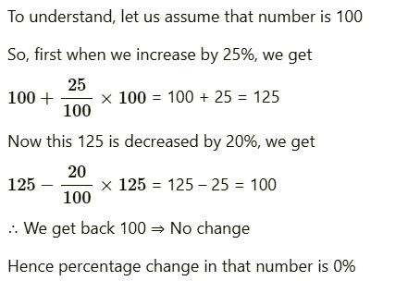

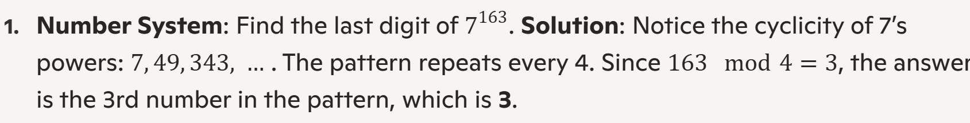
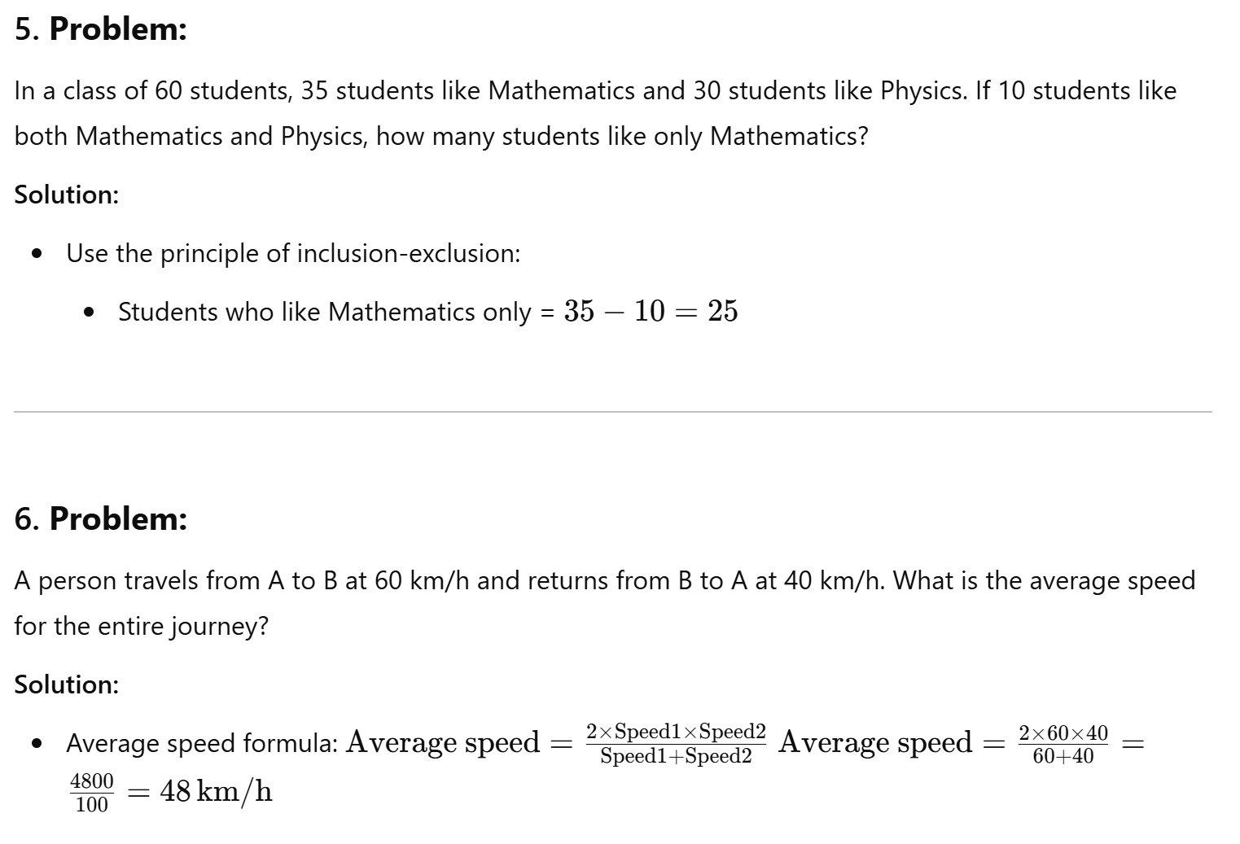
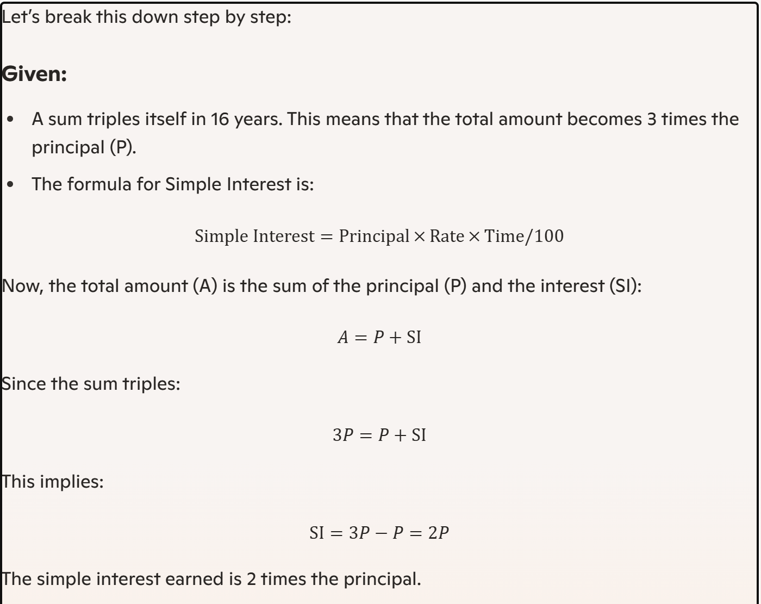

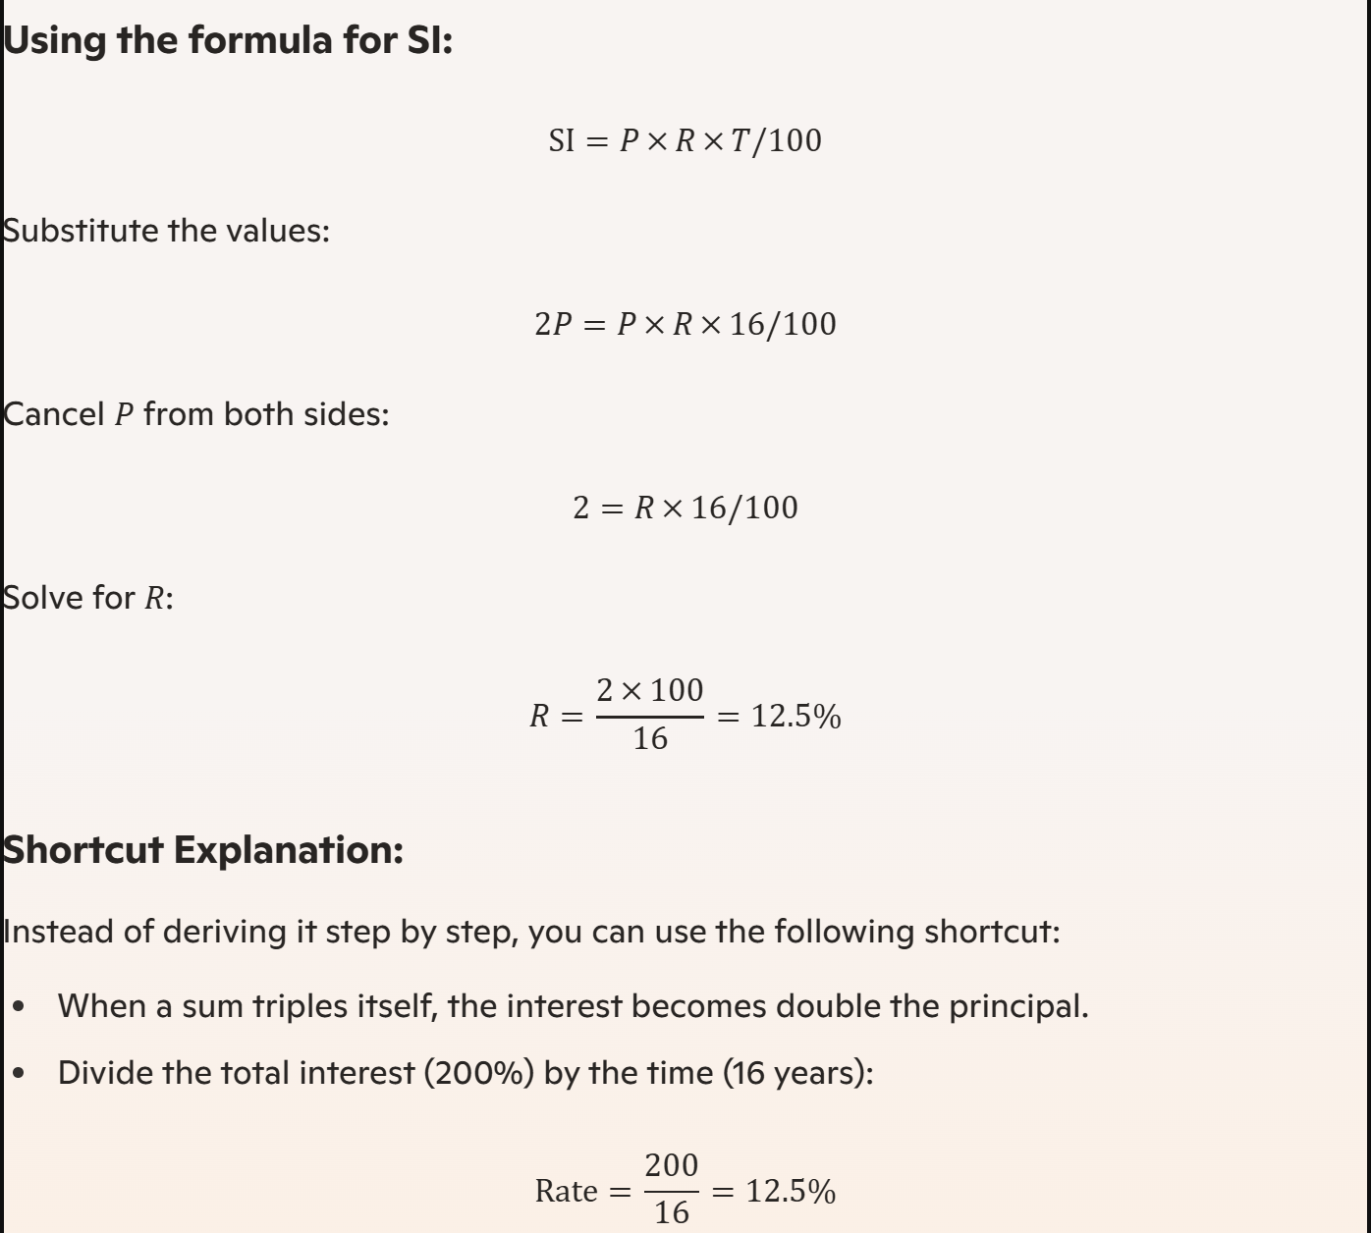

X + y = 15 -> y = 15-x
X, 15-x
15-x = 2x -3
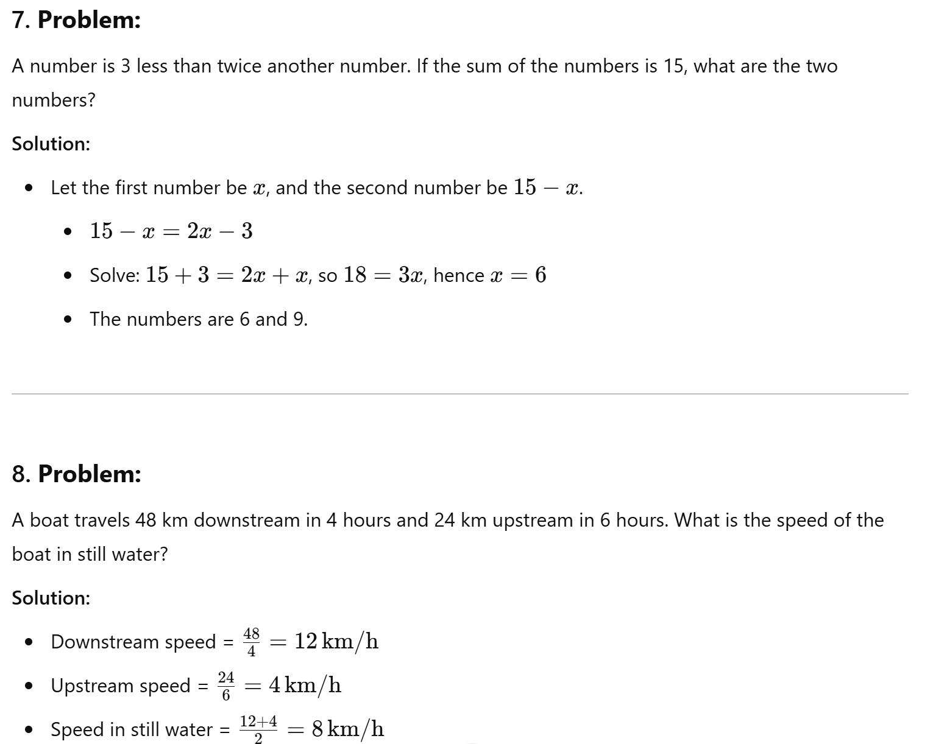
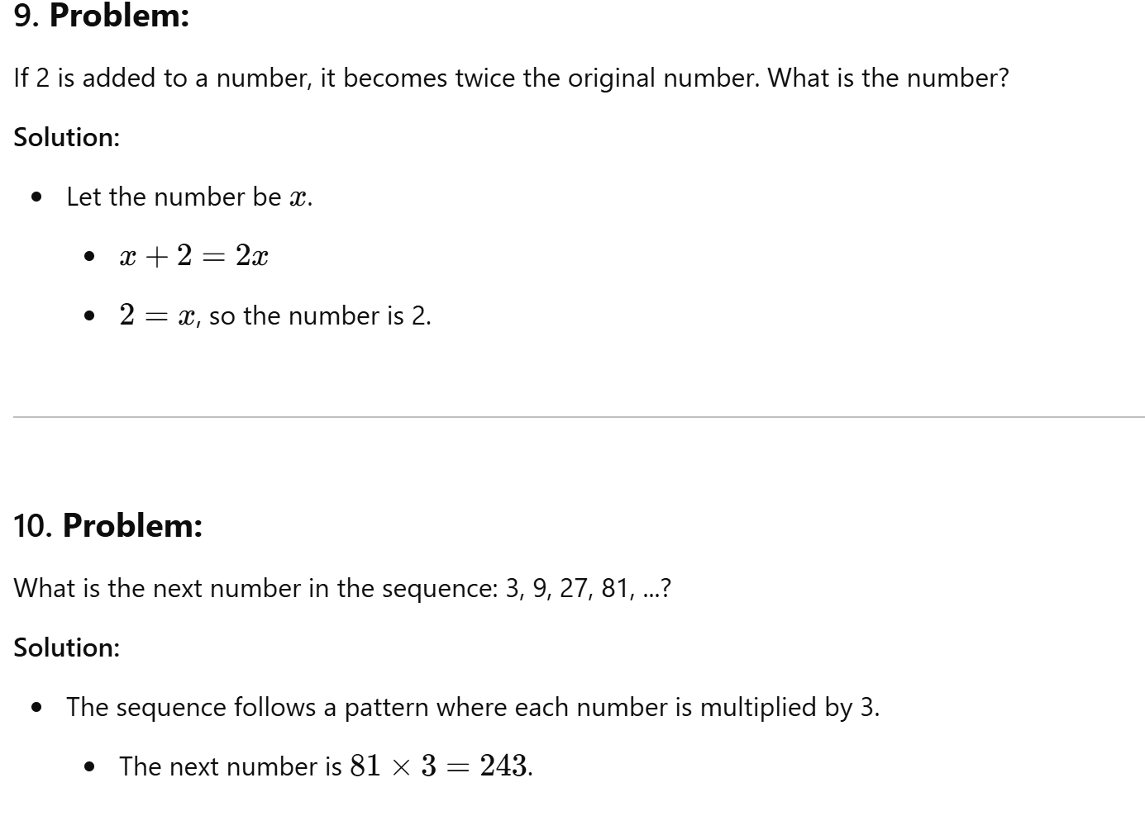
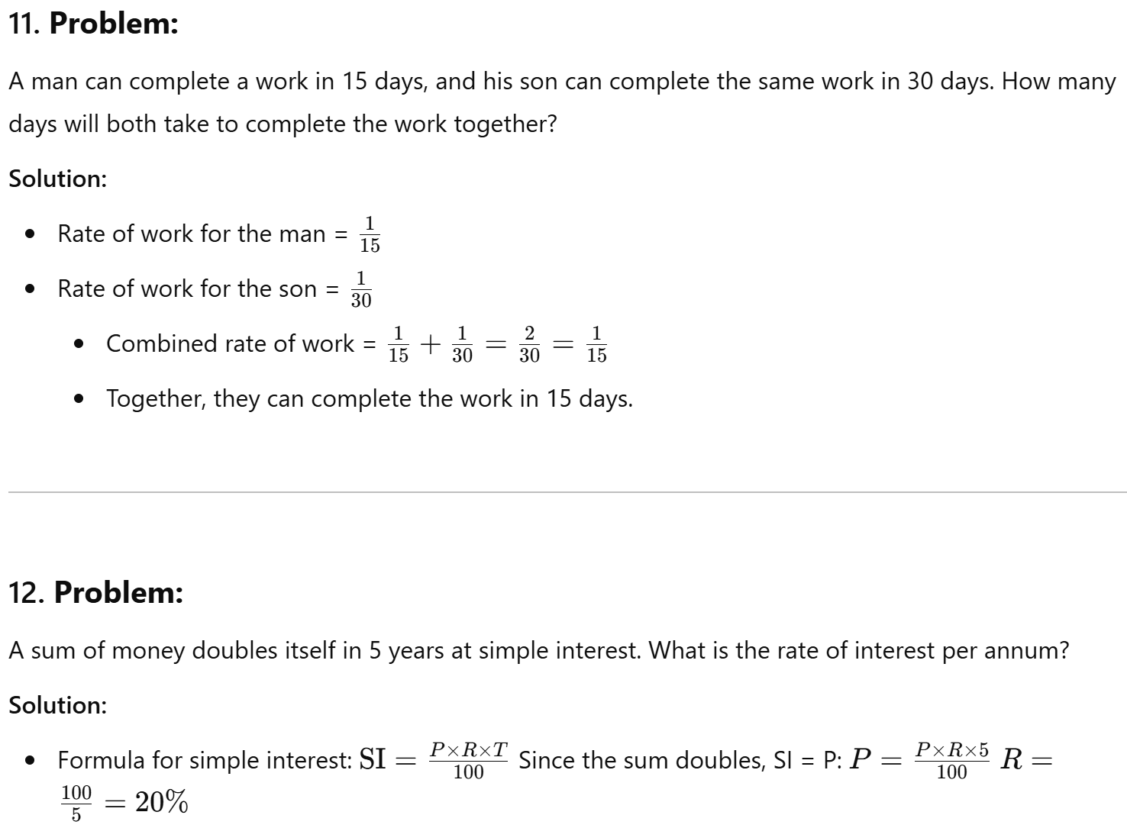
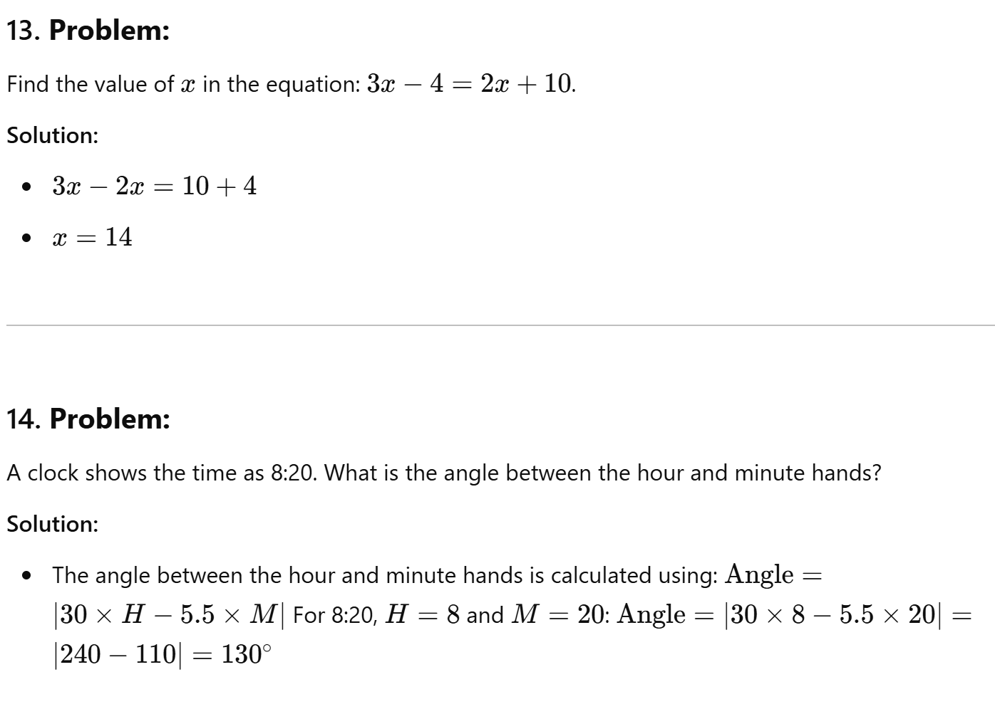
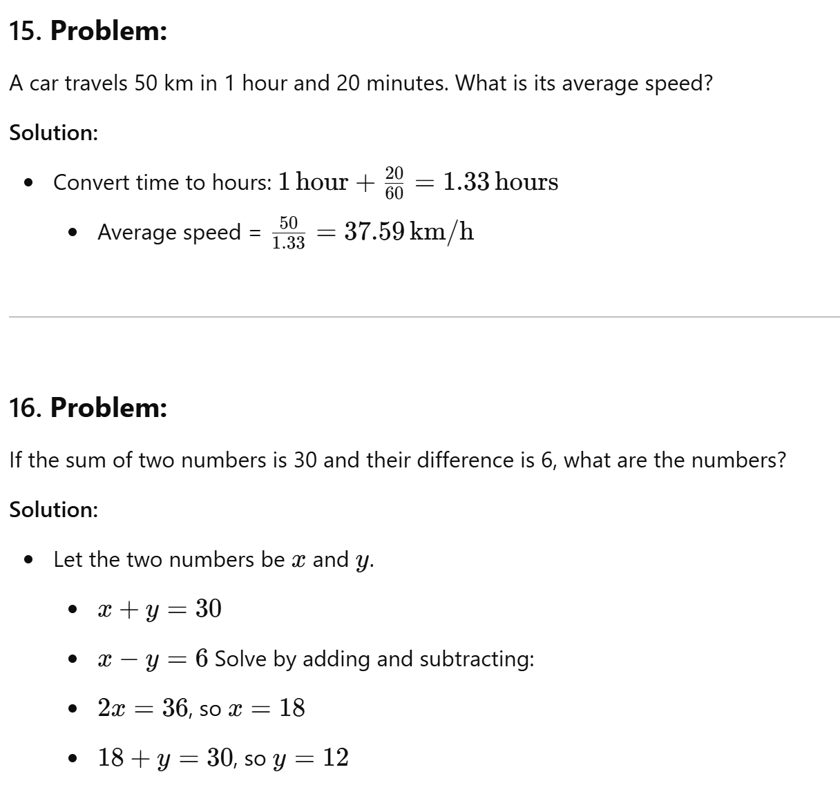
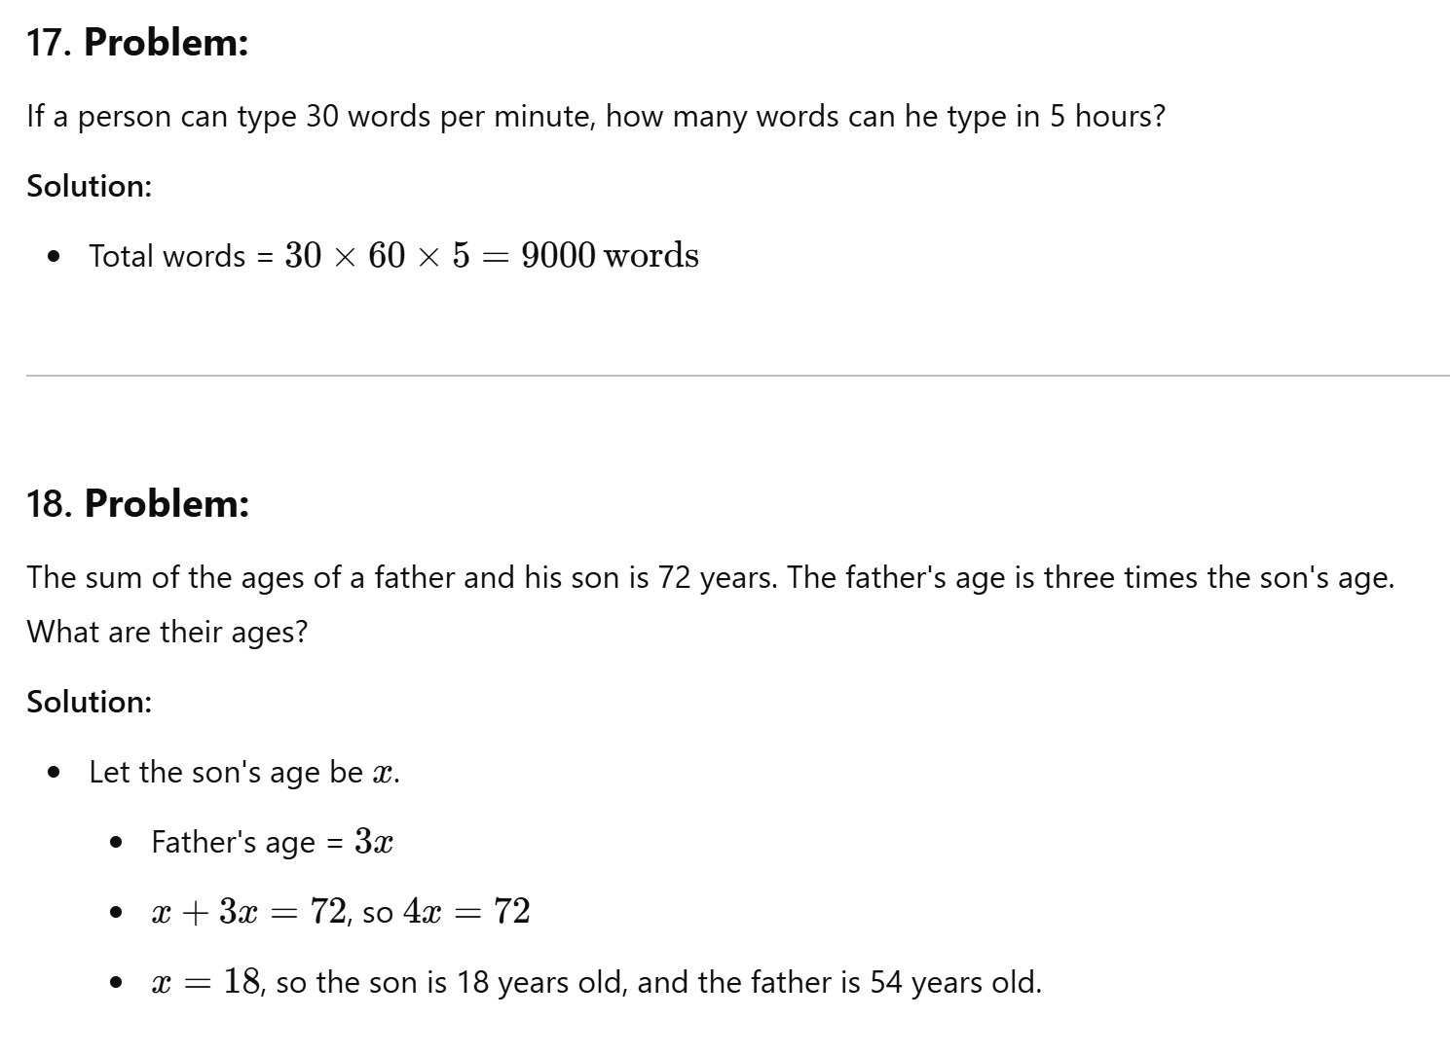
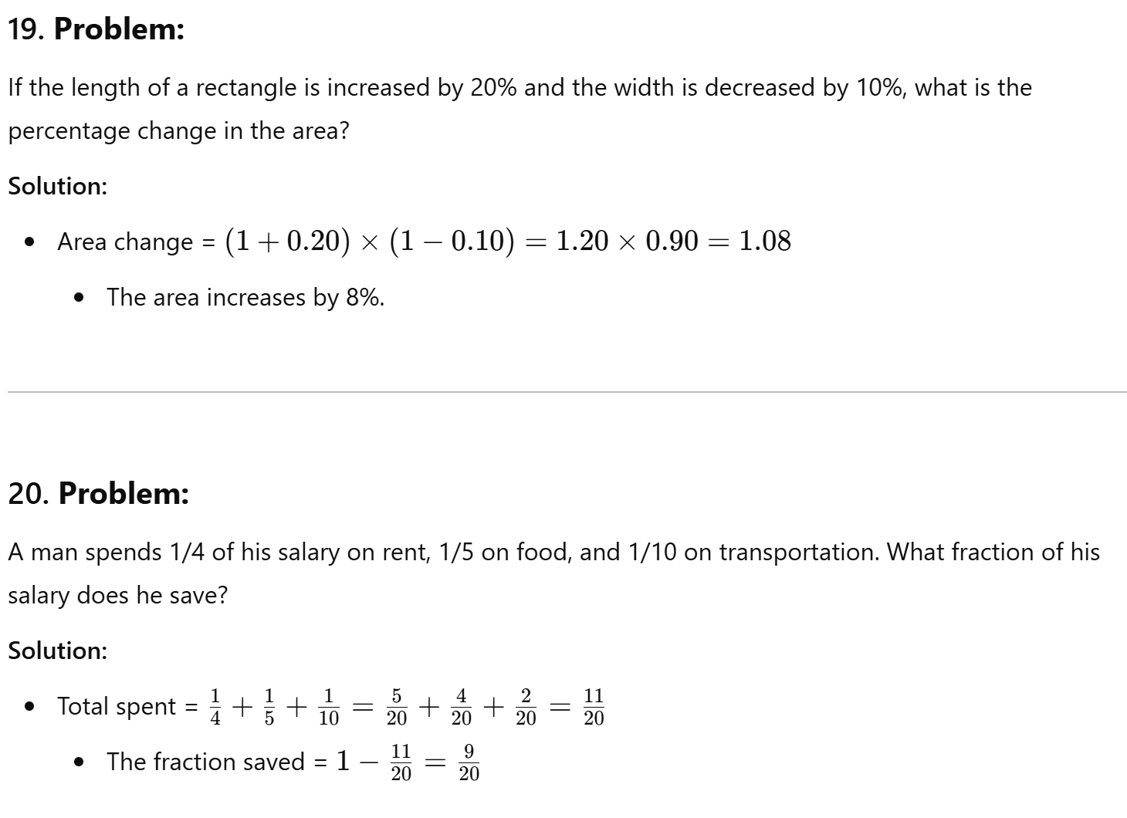
U = A + B – AnB + x 40 = 20+25-5+x 40=40+x
At a conference, 12 members shook hands with each other before & after the meeting. How many total number of hand shakes occurred?
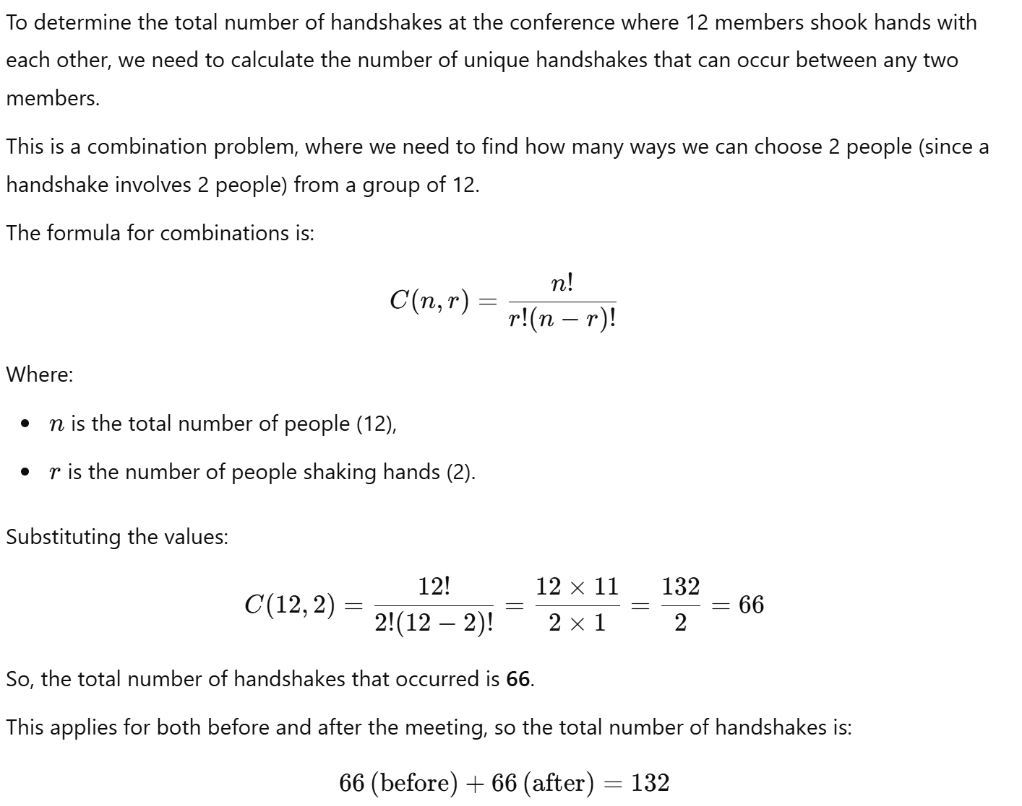

A student has to obtain 33% of the total marks to pass. He obtained 124 marks and failed by 40 marks. Find the total marks.
164 – pass mark
33%
33/100 * T = 164
Out of 100 35 marks – pass. Pass percent – 35
(Pass %)35/100 * 100 = 35 (pass mark)
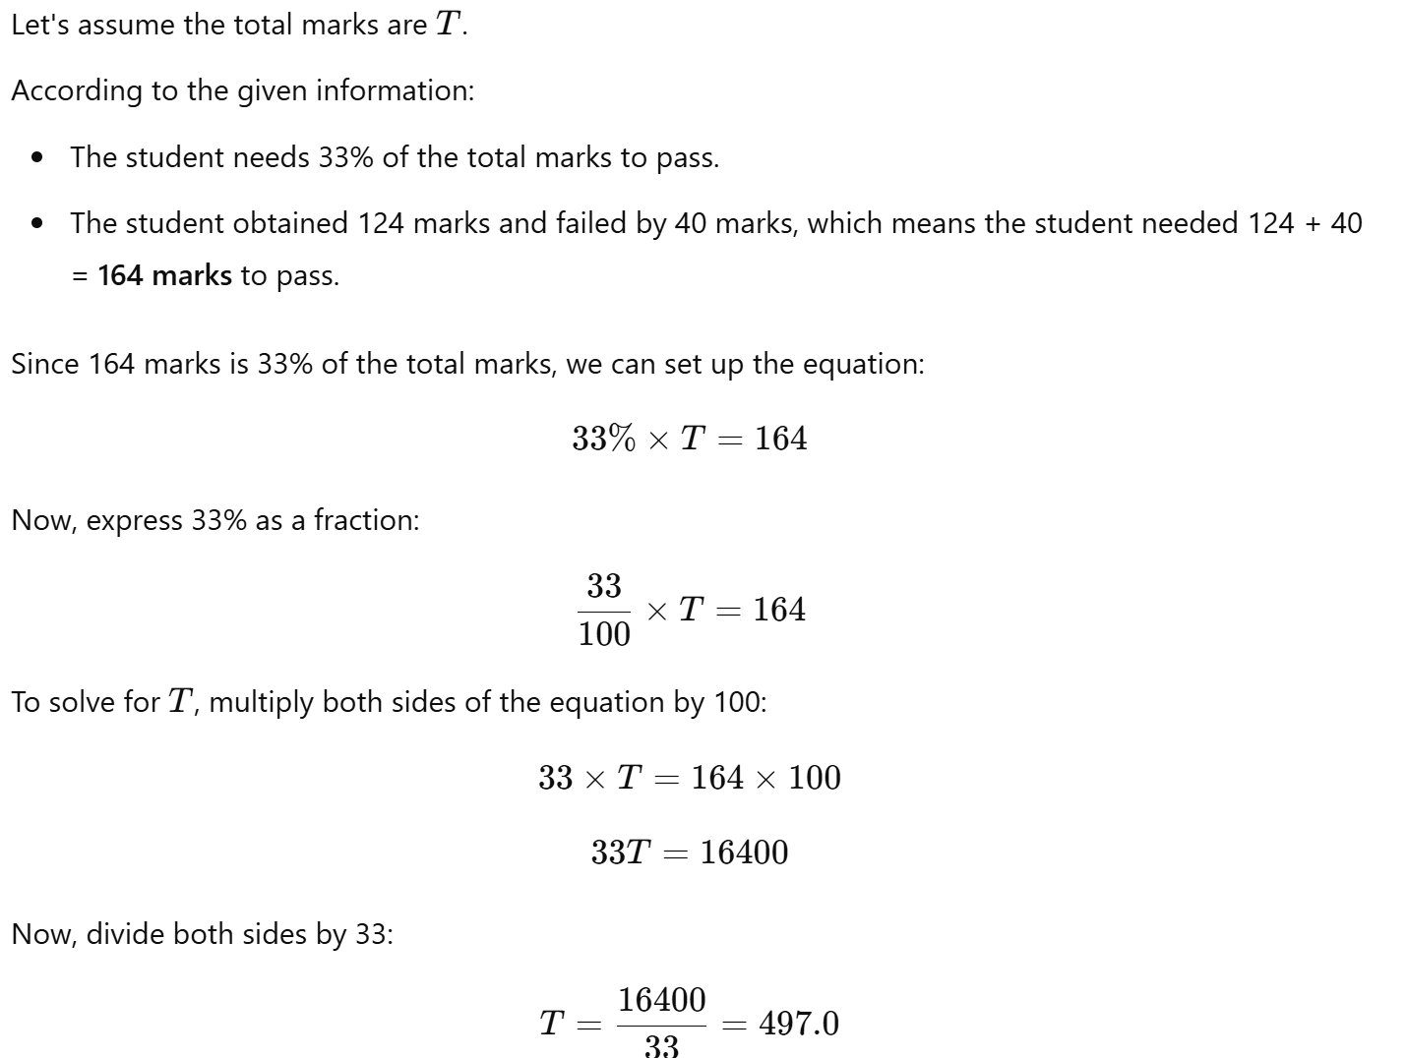

In a kilogram, there are 5 packets of Equal weight. Each packet can make any 4 notebooks of 180 pages each. What is the maximum number of 300-page notebooks that can be made from 3 kg of the same type of paper?
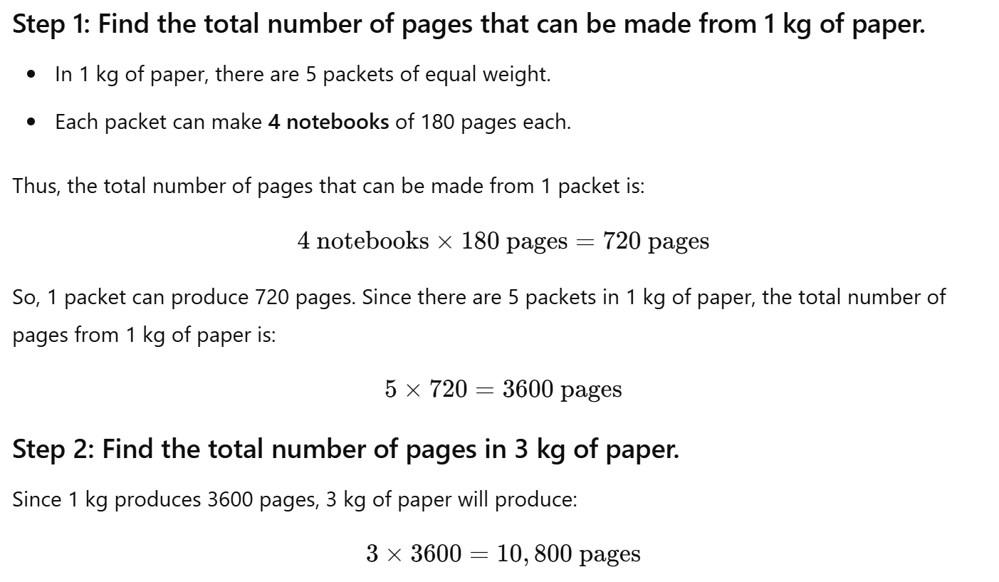
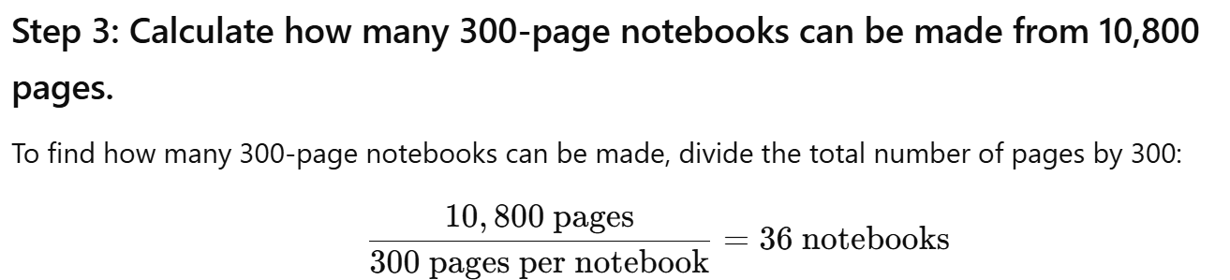

How many 3-letter words can be formed from the word CARTON without repetition?
  - 6- 5- 4-
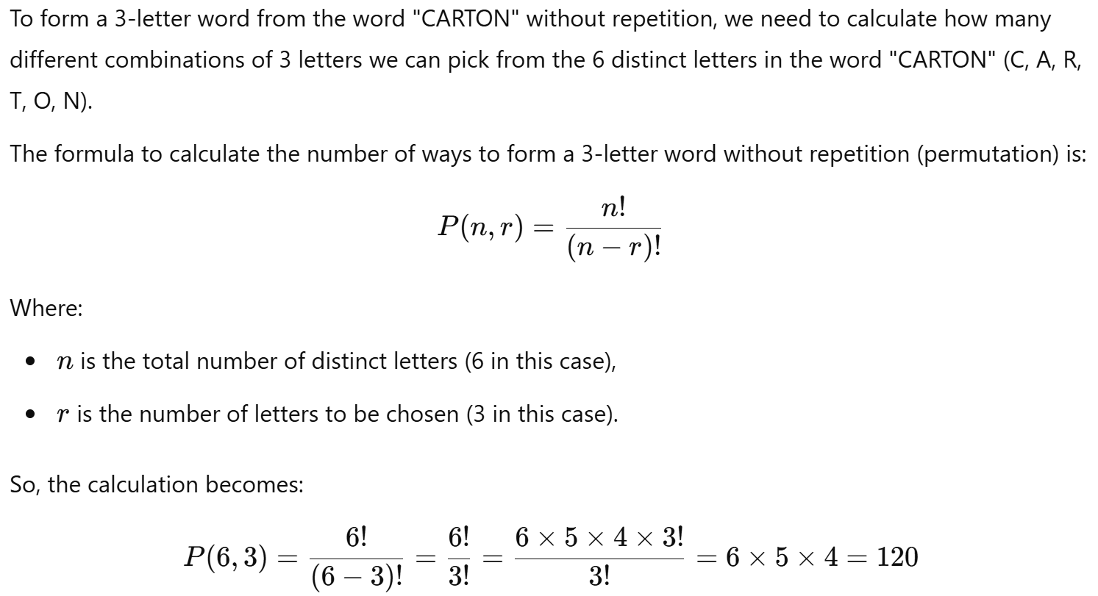
Today is Monday. After 61 days, what day will it be?
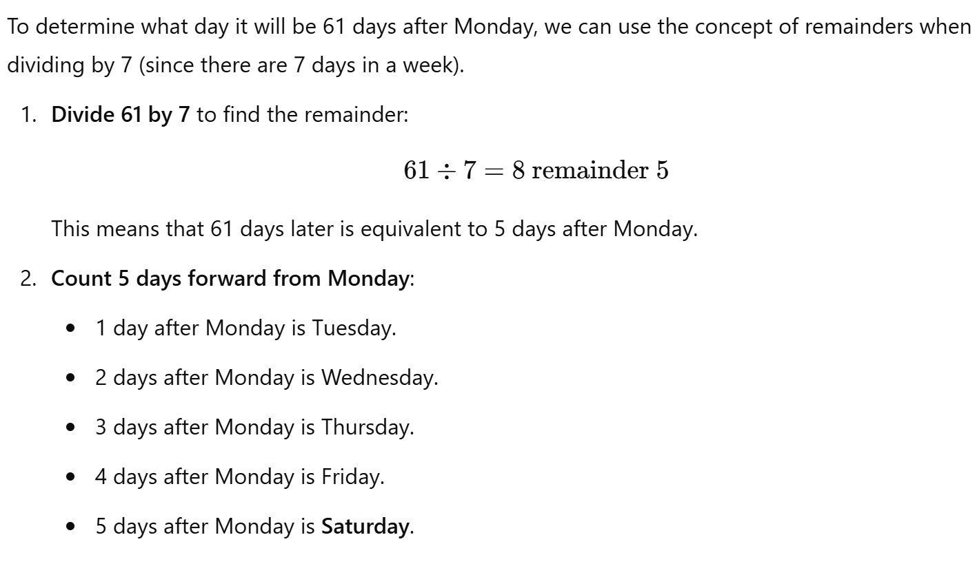

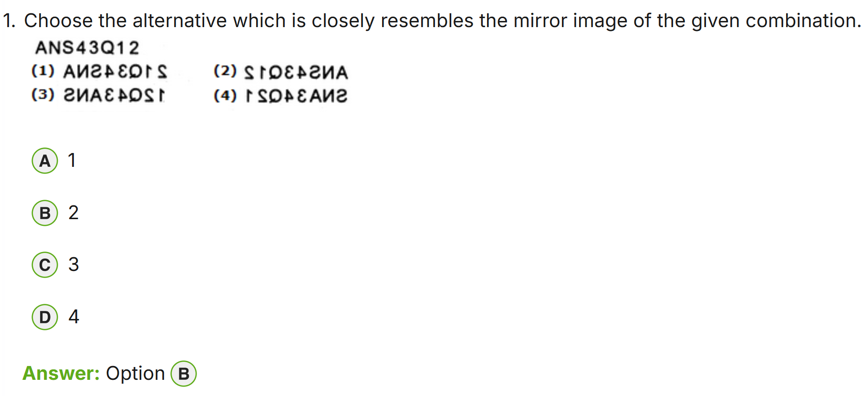
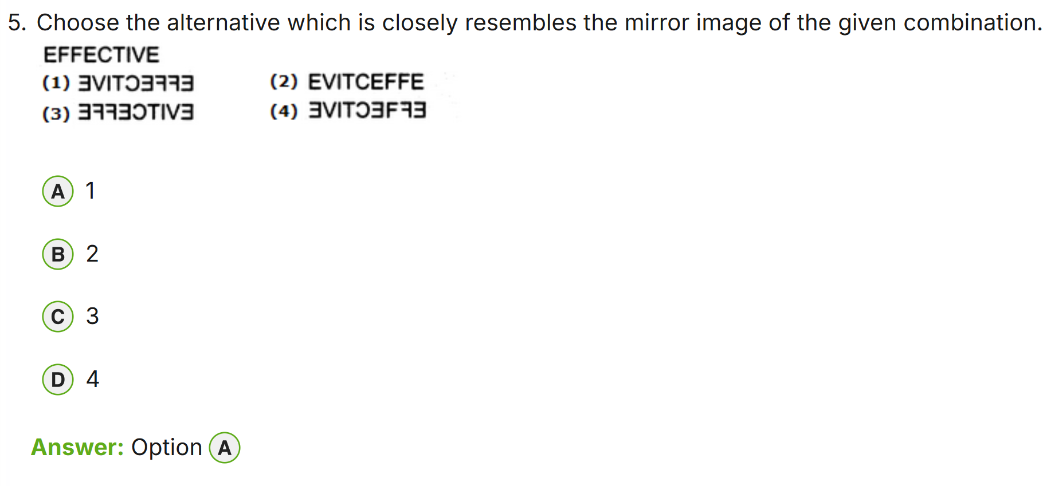
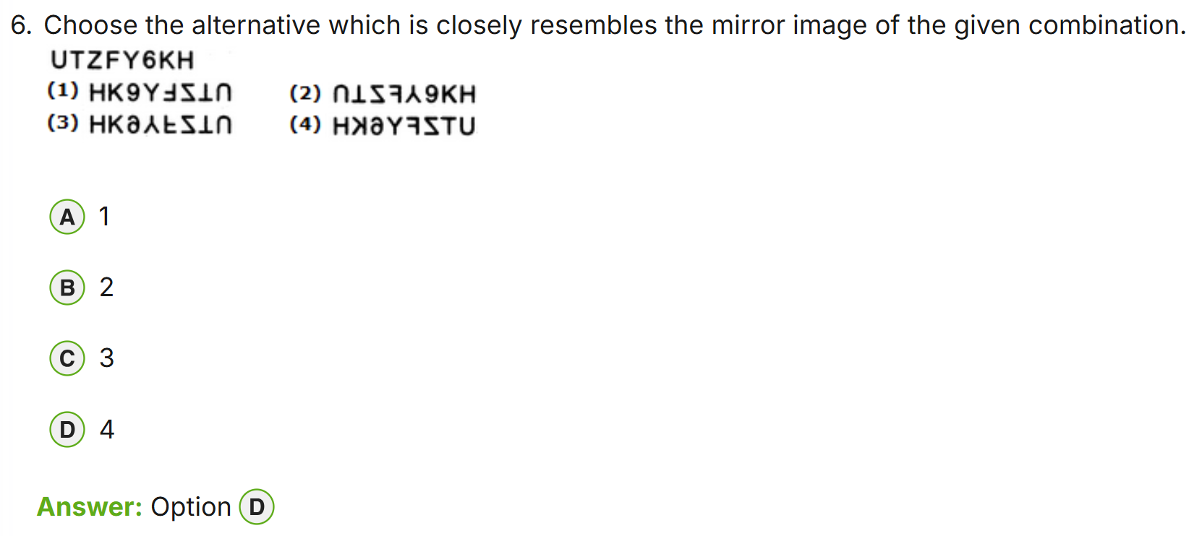
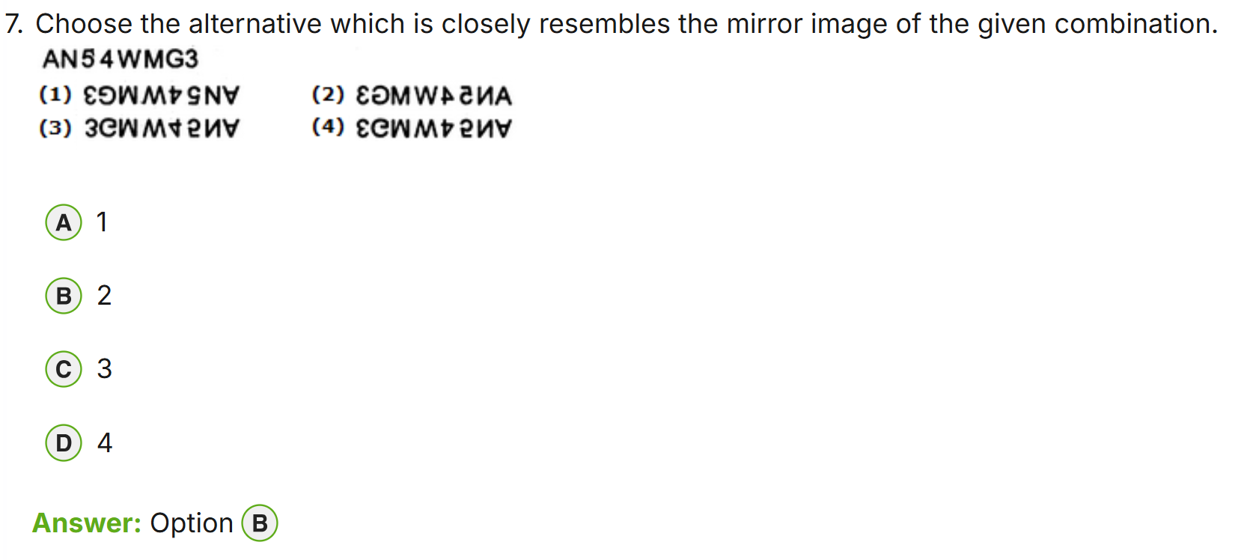
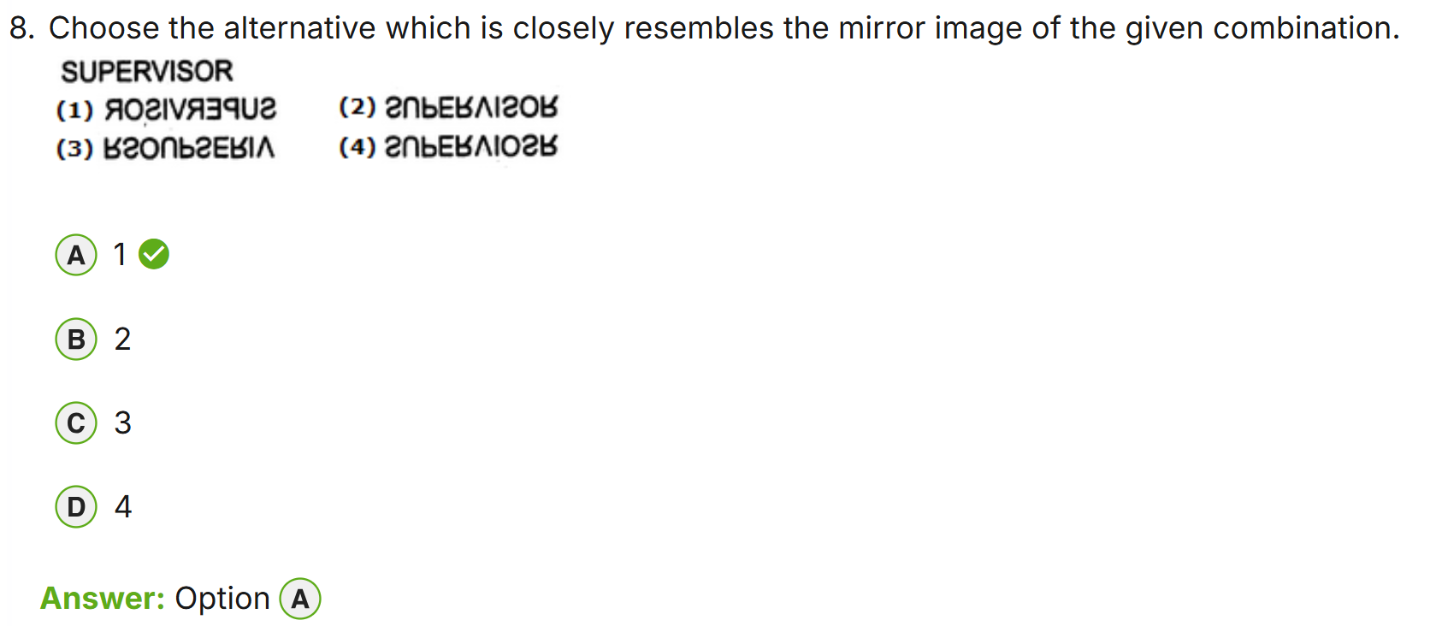
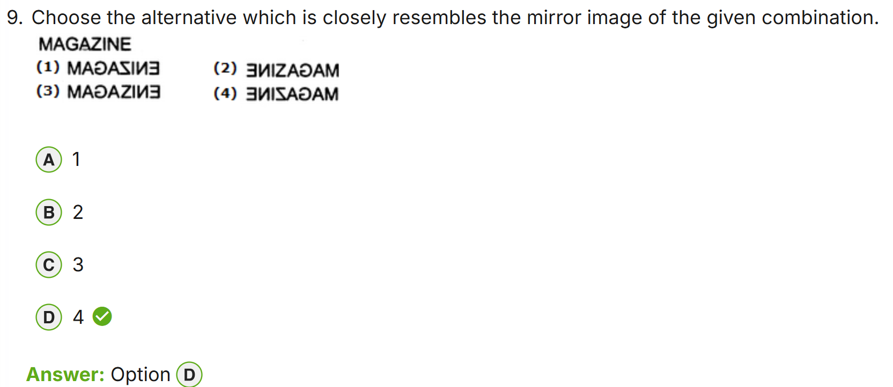
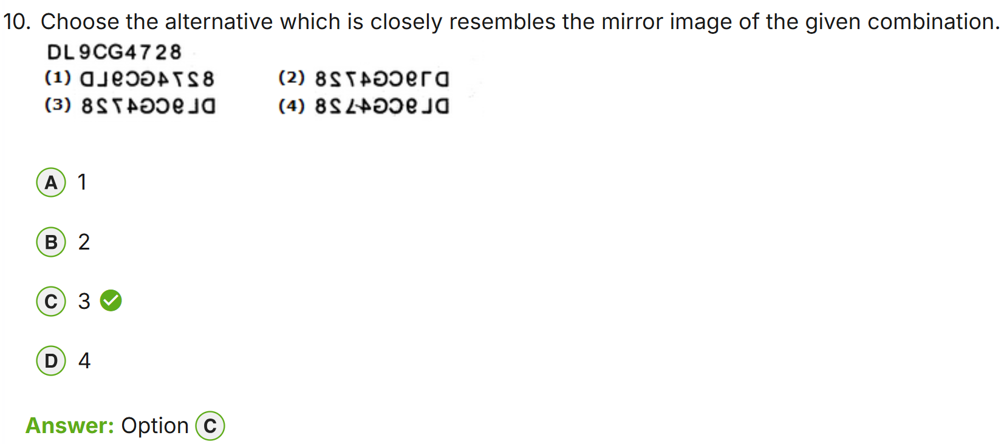

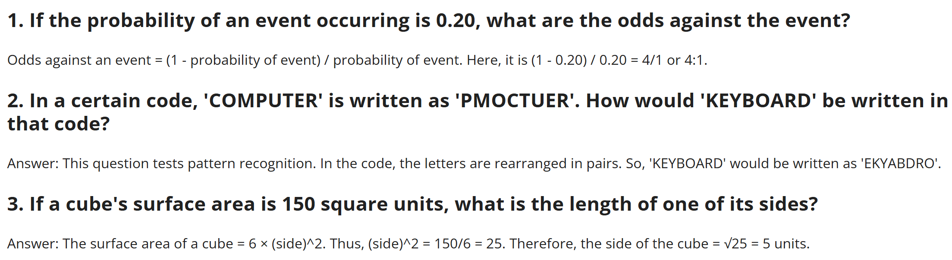
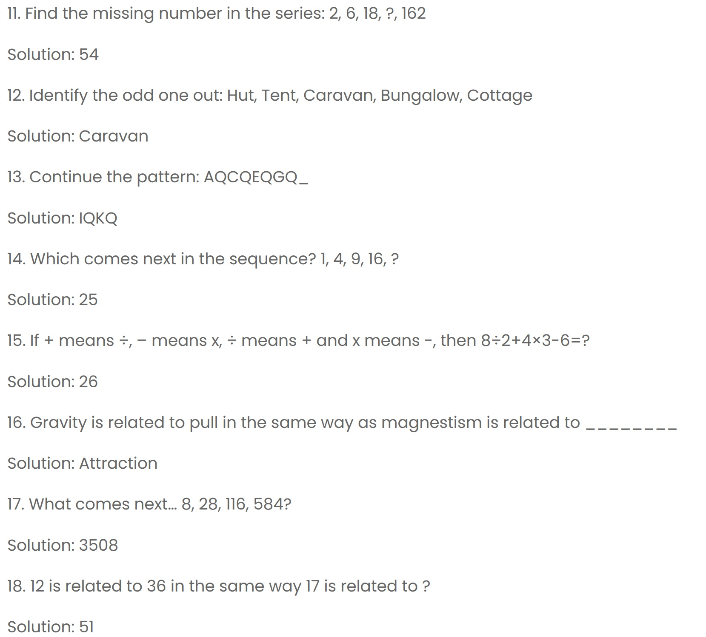
8/2+4*3-6 8+2/4-3*6 8 + ½ - 18
BODMAS – bracket, of, div, mul, add, sub
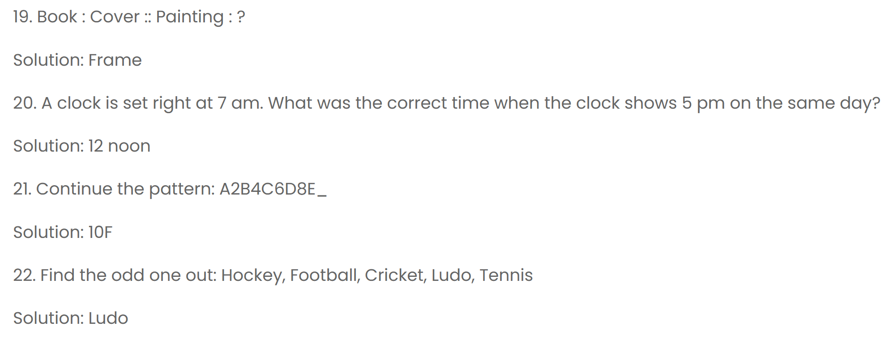
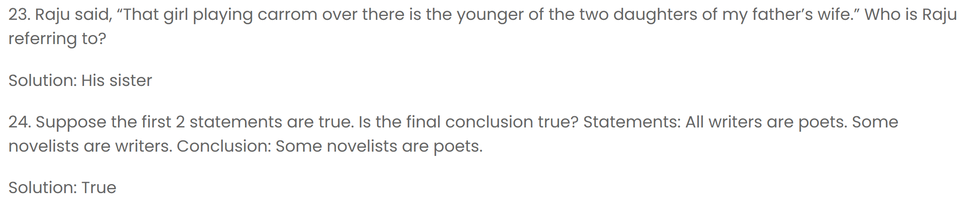
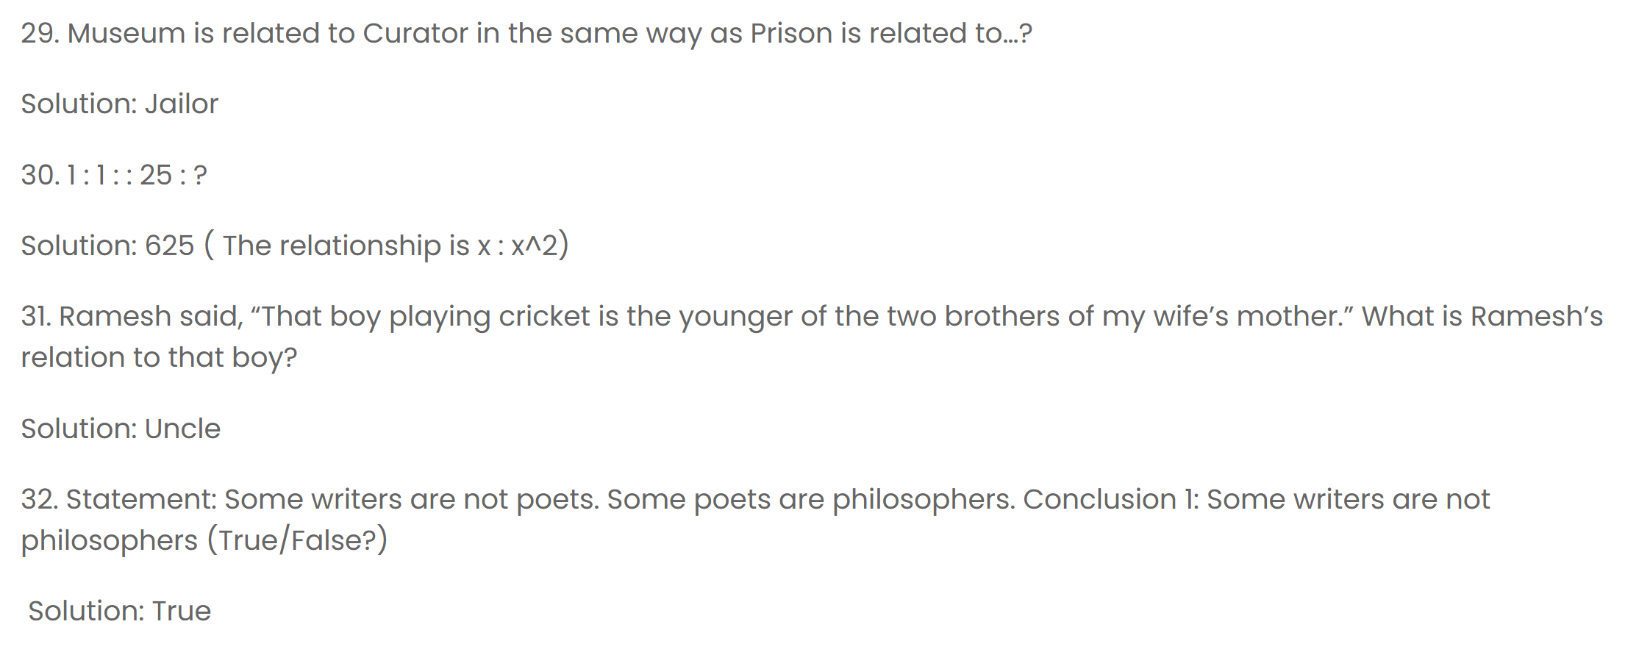
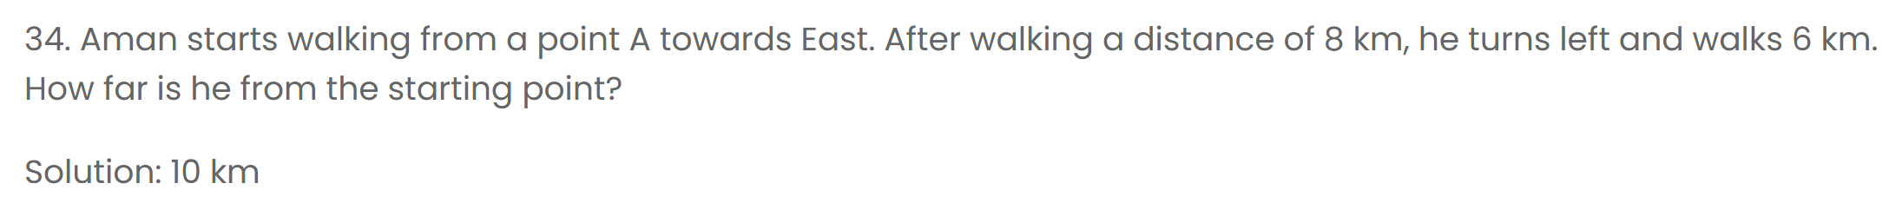

For topics & more sample questions:
https://www.indiabix.com/
https://testbook.com/
https://www.geeksforgeeks.org/aptitude-questions-and-answers/?ref=gcse_ind
https://www.sawaal.com/aptitude-reasoning-questions-and-answers.html
https://byjus.com/govt-exams/list-of-government-exams-articles/
And more…

